**“SENSING HARMFUL GASES IN INDUSTRIES USING IOT AND WSN”**

A Project Report Submitted in the partial fulfillment of requirement of the Degree of

Bachelor of Engineering

in

Computer Technology

Rashtrasant Tukdoji Maharaj Nagpur University, Nagpur

Under the guidance of

**Guide Name – Mrs. Snehal Golait**

Submitted by

**RISHIKESH KUMAR**  **AJINKYA GHADOLE**  **TWINKLE PANDEY KOMAL PANDEY** **SAMIKSHA YERPUDE**



DEPARTMENT OF COMPUTER TECHNOLOGY

PRIYADARSHINI COLLEGE OF ENGINEERING, NAGPUR-440019

**2019-2020**

VISION OF INSTITUTE

To become one of the India’s leading engineering institutes in both education & research. We are committed to provide quality & state of the art technical education to our student, so that they become technologically superior & in turn contribute for creating a great society.

MISSION OF INSTITUTE

We commit ourselves to the pursuit of excellence in technical education & promise to uphold the spirit the spirit of professionalism to serve humanity.

VISION OF DEPARTMENT

To excel in creating outstanding academicians and technocrats for valuable contribution to the society and computer engineering field worldwide as per the ever changing needs.

MISSION OF DEPARTMENT

To ensure technical proficiency to meet industrial needs.

To impart ethical and value based education for social cause.

To encourage the students for carrying out research activities and lifelong learning.

**PRIYADARSHINI COLLGE OF ENGINEERING**

**Department of Computer Technology**

NAGPUR-440019

**CERTIFICATE**

This is to certify that project report entitled - **“Sensing Harmul Gases in Industries using IOT and WSN”** is a bonafide work done by the student **RISHIKESH KUMAR ,AJINKYA GHADOLE , TWINKLE PANDEY , KOMAL PANDEY and SAMIKSHA YERPUDE .** The project report is submitted to **Rashtrasant Tukadoji Maharaj Nagpur University, Nagpur** in partial fulfillment of the requirements for the degree of **Bachelor of Engineering in Computer Technology.**

**Session 2019-2020**

**GUIDED BY- Mrs. Snehal Golait**

Dr. N.M. Thakare Dr. M.P. Singh

H.O.D, Computer Technology, P.C.E. Principal, P.C.E.

**PRIYADARSHINI COLLGE OF ENGINEERING,**

**NAGPUR-440019 (INDIA)**

**Department of Computer Technology**

**DECLARATION**

We, the undersigned, declare that the project entitled **“Sensing Harmul Gases in Industries using IOT and WSN”,** being submittedin partial fulfillment for the award of Degree in Computer Technology, affiliated to RASHTRASANT TUKDOJI MAHARAJ NAGPUR UNIVERSITY, is the work carried out by us.

**Place: NAGPUR PROJECTEES: -**

**Date: 25.04.20 RISHIKESH KUMAR**

**AJINKYA GHADOLE**

**SAMIKSHA YERPUDE**

**TWINKLE PANDEY**

**KOMAL PANDEY**

**ACKNOWLEDGEMENT**

It is our pleasure to acknowledge our sincere thanks with a deep sense of gratitude towards our project guide “Mrs. Snehal Golait**”**, Assistant Professor, Computer Technology Department for her continuous knowledge and support in conducting this dissertation work. She has a whole heartedly helped us in this endeavor at all stages of this work.

We are thankful to **Dr. M.P. Singh**, Principal, Priyadarshini College of Engineering, Nagpur, for providing the facilities at the institute.

We thank **Dr. N.M. Thakare**, Professor and Head of Computer Technology Department of Priyadarshini College of Engineering, Nagpur.

We herewith express our immense thanks to **“**Mrs. Snehal Golait**”, Assistant Professor**, Assistance Professor, Computer Technology Department, Priyadarshini College of Engineering, Nagpur for giving us suggestions and co-ordination with us from time to time as the project in charge.

We also take the opportunity to thank all, who have directly or indirectly extended help and encouragement in executing this project.

**PROJECTEE:**

**RISHIKESH KUMAR**

**AJINKYA GHADOLE**

**SAMIKSHA YERPUDE**

**TWINKLE PANDEY**

**KOMAL PANDEY**

**INDEX**

**CHAPTER 1: INTRODUCTION**

**CHAPTER 2: LITERATURE REVIEW**

**CHAPTER 3: OBJECTIVES**

**CHAPTER 4: ARCHITECTURE**

**CHAPTER 5: ALGORITHMS**

**CHAPTER 6: DATA FLOW DIAGRAM**

**CHAPTER 7: MODULES**

**CHAPTER 8: SCREENSHOTS**

**CHAPTER 9: SOFTWARE REQUIREMENTS**

**CHAPTER 10: CODING**

**CHAPTER 11: APPLICATION AREA**

**CHAPTER 12: FUTURE SCOPE**

**CHAPTER 13: CONCLUSION**

**CHAPTER 14: REFERENCES**

**PAPER PUBLISHED , CERTIFICATES & POSTER**

##### TABLE OF CONTENTS

##### Chapter No. Title Page No. ABSTRACT

##### LIST OF TABLES xvi

##### LIST OF FIGURES xviii

##### LIST OF SYMBOLS xvii

1. **INTRODUCTION 5**
   1. GENERAL
   2. INDUSTRIAL AIR POLLUTION
   3. AIR QUALITY AND ITS HEALTH EFFECT
   4. ACCIDENTS BY HARMFUL GASES
2. **LITERATURE REVIEW 10**
   1. AIR QUALITY INDEX
   2. ROLE OF HARMFUL GASES IN AIR POLLUTION
3. **OBJECTIVES 16**
4. **ARCHITECTURE 20**
   1. ARCHITECTURE OF WSN
   2. ARCHITECTURE OF IOT
5. **ALGORITHMS 27**
6. **DATA FLOW DIAGRAM 32**
7. **MODULES 40**
   1. HARDWARE REQUIREMENTS
   2. ARDUINO
   3. PCB BOARD
8. **SCREENSHOTS 50**
9. **SOFTWARE REQUIREMENTS 55**
   1. MS VISUAL STUDIO
   2. MS SQL SERVER
10. **CODING 65**
11. **APPLICATION AREA 70**
12. **FUTURE SCOPE 75**
13. **CONCLUSION 78**
14. **REFERENCES 83**
15. **PAPER PUBLISHED , CERTIFICATES 85**

**ABSTRACT**

This paper reviews the gas sensors according to the hazard limits and introduces a model of IOT based gas sensor. It is also containing a market review based on previous year’s gas sensor global market, nevertheless special types of gas sensors also noted in this paper. According to WHO the world is facing a tremendous climate change in recent years, which mainly focused on the increasing number of hazardous gases limit in atmosphere. Moreover, the EU also declares to fulfil worker safety from the hazardous effect from the poisonous gases of production wastes. So it can be said that it is the alarming period of being aware and acquire knowledge about the gases, importantly how to get primary solution of it. Study of hazardous gases, specially their hazardous limits and the detection process of them can be a primary solution of being aware of any miserable explosion occurred by hazardous gases. This paper will help to give a clear overview of this kind of situation. Moreover, this paper can be a study of gas sensors which will be helpful for our upcoming global changes.

LIST OF TABLES

|  |  |  |
| --- | --- | --- |
| **TABLE** | **TITLE** | **PAGE** |
| 1.1 | Air Quality Index of Criteria Air Pollutants | 4 |
| 1.2 | Criteria Air Pollutants, Sources and Adverse Effects | 9 |
| 1.3 | Air Pollution related Episodes and Accidents | 12 |
| 2.1 | Contribution of air pollution from various sources in Delhi in percentage during the periods 1970-71 to 2000-01 | 26 |
| 3.1 | Total number of Motor Vehicles registered in | 49 |
|  | Chennai during the years 1981 to 2012 |  |
| 4.1 | Gas sensors used in the AQMD | 56 |
| 4.2 | Features of the sensors used in the AQMD | 61 |
| 5.1 | Locations of Static Monitoring Stations S1 to S12 | 79 |
| 5.2 | Maximum, Minimum and Average pollutants’ concentrations observed at Poonamallee (S1) | 81 |
| 5.3 | Maximum, Minimum and Average pollutants’ | 82 |
|  | concentrations observed at Porur (S2) |  |
| 5.4 | Maximum, Minimum and Average pollutants’ concentrations observed at Ashok Nagar (S3) | 83 |
| 5.5 | Maximum, Minimum and Average pollutants’ concentrations observed at Tambaram (S4) | 84 |
| 5.6 | Maximum, Minimum and Average pollutants’ concentrations observed at Pallavaram (S5) | 85 |
| 5.7 | Maximum, Minimum and Average pollutants’ concentrations observed at Guindy (S6) | 86 |
| 5.8 | Maximum, Minimum and Average pollutants’ | 87 |
|  | concentrations observed at Avadi (S7) |  |

LIST OF FIGURES

|  |  |  |
| --- | --- | --- |
| **FIGURE** | **TITLE** | **PAGE** |
| 1.1 | Picture depicting the natural and manmade sources | 3 |
|  | of Air Pollution and release of specific Air Pollutants |  |
| 1.2 | Picture depicting the top 10 risk factors for disease in 2010 in Asia (mainly India) | 10 |
| 1.3 | Picture showing the contributors of air pollution in percentage in urban areas | 14 |
| 2.1 | Picture depicting the deaths attributable to ambient | 23 |
|  | air pollution in 2012, by disease |  |
| 2.2 | Picture depicting the deaths attributable to ambient air pollution in 2012, by age and sex | 24 |
| 2.3 | Picture shows the contributors of air pollution in | 26 |
|  | two of the metropolitan cities of India: Delhi and Chennai |  |
| 2.4 | Picture shows one of the methods of air pollution | 35 |
|  | control by the way of real time air pollution monitoring |  |
| 2.5 | Sensor board with different gas sensors (processing unit) and Libelium Wasp mote (communication | 36 |
|  | unit) |  |
| 2.6 | Multihop mesh network system architecture for the real time wireless pollution monitoring system | 37 |
| 3.1 | Chennai Metropolitan Area depicting the Chennai District and parts of Tiruvallur and Kanchipuram Districts. | 42 |
| 3.2 | Total number of Motor Vehicles registered in India | 47 |
|  | during the years 1951 to 2012 |  |

**CHAPTER 1: INTRODUCTION**

# General

Published data of World Health Organisation (WHO) reveal about 3.7 million deaths from outdoor air pollution in 2012, of which nearly 90% were in developing countries (Associated Press 2014). India is one of the fastest developing countries in the world owing to the economic reforms initiated by the Government of India in 1991. The centres of economic reforms are liberalisation, privatisation and globalisation (Saritha 2014). These have led to the good growth of Indian economy, living standard and life style of people of India rapidly, leading to greater use of private motorised vehicles than public transportation systems, since the latter have not improved at the pace that the private vehicles grown.

Traffic composition in India is of a mixed nature. A wide variety of about a dozen types of both slow and fast moving vehicles exists. Two wheelers and cars (including jeeps) account for more than 80 % of the vehicle population in most large cities (Sanjay 2005). The share of buses is negligible in most Indian cities when compared to personalised vehicles whose population share was more than 90% during the year 2000.

The transportation sector is the major contributor to air pollution in urban India. For example, 72% of air pollution in Delhi is caused by vehicular emission. The quantum of emissions generated from motor vehicles in Delhi has seen a big jump from 23% in 1970-71 to 72% in 2000-01 whereas emissions from industrial and domestic sectors together decreased from 77% to

28% in the corresponding years (Sanjay 2005). According to WHO, *air pollution* caused about one in eight deaths and has now become the single biggest environmental health risk.

# Industrial Air Pollution

*Industrial Air pollution* is defined as any atmospheric condition in which certain substances are present in such concentration and duration that they may produce harmful effects on living beings and the environment (Mulaku 2001). Gaseous and particulate substances such as carbon monoxide (CO), sulphur dioxide (SO2), nitrogen dioxide (NO2), ozone (O3) and particulate matter (PM10 and PM2.5), and lead (Pb) are designated as *criteria air pollutants* by the United States of Environmental Protection Agency (USEPA) and Central Pollution Control Board (CPCB) in India, as they are primarily responsible for adverse health effects on living being and their properties including vegetation.

*Air Pollutants* are the substances which, when present in the atmosphere, cause serious health hazards to the flora and fauna, or microbial life; damage materials, or interfere with the enjoyment of life and the use of property (Glynn and Gary 2004).

The atmospheric layer on the surface of the earth (known as troposphere) is a complex dynamic natural gaseous system that is essential for support to life on the planet Earth. The depletion of stratospheric ozone layer due to air pollution has been recognized as a threat to human health as well as to Earth's ecosystems. Indoor air pollution and urban air pollution are listed as two of the World’s worst air pollution problems in the 2008 by Blacksmith Institute’s report on World's Worst Polluted Places (Blacksmith Institute’s report 2008). In this report, air pollution is defined as the introduction of chemicals, particulate matter, or biological materials into the atmosphere that

cause harm or discomfort to humans or other living organisms, or cause damage to the natural environment or built environment.

Air can be contaminated with pollutants from *anthropogenic activities* such as industrial and domestic activities and mobile sources. It includes use of motorised vehicles for transportation, thermal power plants, burning of municipal solid wastes and road side solid wastes including tyres and other plastic wastes, construction activities, etc. N*atural sources* such as seasonal wind and dust storms, volcano eruptions, forest fires, etc. also cause air pollution occasionally. The major natural and manmade sources of air pollution and release of specific air pollutants from various sources are depicted in Figure 1.1.

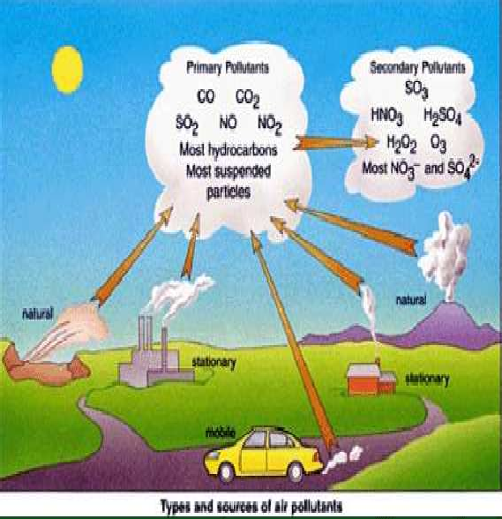

# Figure 1.1 Picture depicting the natural and manmade sources of Air Pollution and release of specific Air Pollutants

Threshold limits for air pollutants have been arrived at, in order to regulate the ambient air quality to which people are normally exposed in their day to day life. Almost all the countries have prescribed their own ambient air quality standards. India’s National Ambient Air Quality Standards (NAAQS)

are given in *Appendix 1*. In the absence of such standards, the pollution data obtained is compared with the Air Quality Index (AQI) (Mahboob and Makshoof 2008). The AQI is a rating scale for outdoor air suggested by the United States Environmental Protection Agency (US EPA) which is presented in the Table 1.1.

# Table 1.1 Air Quality Index of Criteria Air Pollutants

|  |  |  |  |  |  |
| --- | --- | --- | --- | --- | --- |
| AQI Category | AQI  Rating | PM10  (µg/m3) | CO  (ppm) | NO2 (ppm) | SO2 (ppm) |
| Very good (0-15) | A | 0-50 | 0 – 2.0 | 0 – 0.02 | 0 – 0.02 |
| Good (16-31) | B | 51-75 | 2.1 – 4.0 | 0.02 – 0.03 | 0.02 – 0.03 |
| Moderate (32-49) | C | 76-100 | 4.1 – 6.0 | 0.03 – 0.04 | 0.03 – 0.04 |
| Poor (50-99) | D | 101-150 | 6.1 – 9.0 | 0.04 – 0.06 | 0.04 – 0.06 |
| Very Poor (100 or  over) | E | >150 | >9.0 | >0.06 | >0.06 |

The AQI is calculated by using the following formula.

��� = ��������� ���� �������� �100 ………………………1.1

���������

��������� ���� ��������

# Air Quality and Health Effects of Air Pollution

People can live without water for a few days. But, living without breathing air even for a few moments is unimaginable. The air breathed directly gets into bloodstream. Air pollutants have long been a major concern because of the harmful effects that they have on people’s health and the environment. Hence, it is necessary to ensure that air quality is not polluted beyond the threshold limits.

Clean air is a basic requirement of human health. People are exposed to outdoor air pollution by breathing in air pollutants and by exposing eyes and skin while they are outdoors. Exposure is intensified by vigorous activity, as

pollutants are drawn more deeply into the lungs during periods of physical exertion. People who live or work in close proximity to emission sources such as power plants, local industries or highways/major roadways are often exposed to a higher concentration of pollutants for longer periods of time which aggravates their risk of developing acute and/or chronic health problems. Long-term exposure to relatively low levels of pollutants can also cause serious health problems.

The extent of adverse impact due to air pollution depends on many factors, including the concentration of air pollution to which people are exposed, the duration of the exposure, and the potency of the air pollutants. The adverse effects of air pollutants can be minor and reversible (for example, eye irritation due to oxides of nitrogen) or debilitating (for example, aggravation of asthma due to volatile organic compounds) or even fatal (for example, formation of carboxyl-hemoglobin in the blood stream when exposed to carbon monoxide).

The past couple of decades have seen a negative impact of urban traffic growth. Increasing air pollution and traffic noise as a sequel to growing urban traffic has become a common experience. Humans can readily see traffic congestion and can hear traffic noise, but inevitably they are much less aware of odourless, invisible, silent air pollution.

Cities in developing countries often suffer heavily from outdoor air pollution due to extensive use of diesel fuel for transport vehicles and the predominant use of coal for power generation. The proximity of urban population to industrial facilities and the lack of advanced emission controls for vehicles and industry are also responsible for most health risks (Blacksmith Institute’s Report 2009).

Air pollution continues to pose a significant threat to health worldwide. According to The World Health Organization (WHO) assessment of the global burden of disease due to air pollution, the impact of air pollution on health is larger than was assessed only a few years ago. This organisation has estimated that in 2012 around 7 million premature deaths resulted from air pollution, more than double the previous estimates. The new estimate is based on increasing knowledge of air pollution related diseases and use of improved air quality measurements and technology. According to WHO, outdoor air pollution caused 3.7 million premature deaths in 2012 and indoor air pollution is responsible for about 4.3 million premature deaths (UNEP Year Book 2014).

“The risks from air pollution are now far greater than previously thought or understood, particularly for heart disease and strokes,” says *Dr Maria Neira*, Director of WHO’s Department for Public Health (WHO-PHE 2014).

“Clean air can’t be bought in a bottle, but cities can adopt measures that will clean the air and save the lives of their people.” “Excessive air pollution is often a by-product of unsustainable policies in sectors such as transport, energy, waste management and industry. In many cases, healthier strategies will also be more economical in the long term due to health-care cost savings as well as climate gains,” says *Dr Carlos Dora*, WHO Coordinator for Public Health, Environmental and Social Determinants of Health (WHO-PHE 2014).

“Cleaning up the air that is being breathed prevents non-communicable diseases as well as reduces disease risks among women and vulnerable groups, including children and the elderly,” says *Dr Flavia Bustreo*, WHO Assistant Director-General Family, Women and Children’s Health (WHO-PHE 2014).

WHO observes that air quality in many cities worldwide that monitor outdoor (ambient) air pollution fail to meet WHO guidelines for safe levels, putting people to additional risk of respiratory diseases and other health problems. “Too many urban centres today are so enveloped in dirty air that their skylines are invisible,” said *Flavia Bustreo*, WHO assistant director- general for family, children and women's health (Vivek 2014). Urban centers are growing faster in India, as seen in *Appendix 2*, within a decade urban areas having population more than a million increased 50% from 34 in 2001 to 51 in 2011.

Key findings from Global Burden of Diseases report 2012 (WHO- Burden of Disease 2012) are as follows;

1. *Increase in death toll*: Air pollution is the fifth leading cause of death in India, with 620,000 premature deaths. This is up from 100,000 in 2000 – a six-fold increase.
2. *Loss in healthy years*: Air pollution is the seventh leading cause behind the loss of about 18 million healthy years of life due to illnesses. It comes after indoor air pollution, tobacco smoking, high blood pressure, childhood underweight, low nutritional status, and alcohol use.
3. *Respiratory and cardiovascular diseases key reasons for air pollution- induced premature deaths*: These diseases include stroke (25.48 per cent), chronic obstructive pulmonary disease (17.32 per cent), Ischemic heart disease (48.6 per cent), lower respiratory infections (6.4 per cent), and trachea, bronchus and lung cancer (2.02 per cent).

Major health hazards associated with outdoor air pollution are chronic pulmonary and cardio-vascular stress, lung cancer, asthma exacerbation, acute and chronic bronchitis, restrictions in activity and lost days of work. Infants, children, women and elderly too are more vulnerable to the outdoor air pollution. People with pre-existing health conditions are also significantly affected (Blacksmith Institute’s report 2008 on Health Effects).

Studies indicate that chronic exposure to NO2 may impair lung development in children and cause structural changes in the lungs of adults. Exposure to ground level ozone (O3) causes burning of eyes and irritation of nose and throat, drying out of mucus membranes reducing the ability of body to resist respiratory infections.

The major sources and adverse effects of criteria air pollutants are tabulated in the Table 1.2.

# Table 1.2 Criteria Air Pollutants, Sources and Adverse Effects

|  |  |  |
| --- | --- | --- |
| Air Pollutant | Sources | Adverse Effects |
| Particulate Matter (PM10) and (PM2.5). | Combustion of fossil fuels, factories, construction,  demolition, agricultural activities, motor vehicles, and wood burning. | Irritation of respiratory tract, aggravated asthma, and increases the risk of chronic obstructive pulmonary diseases. |
| Sulphur dioxide (SO2) | Combustion of sulphur containing fuels. | Irritation of lung tissues, shortness of breath, sore throats, breathing difficulties and can damage overall health and materials. |
| Nitrogen oxides (NO and NO2) | Vehicle Exhaust | Reduced visibility and increase the risk of acute and chronic respiratory disease. |
| Carbon monoxide (CO) | Incomplete combustion of fuels (largest source - motor vehicles). | High concentration levels lead to headache, dizziness, visual acuity, shrinking mental function, unconsciousness, and death. |
| Ozone (O3) | Formed when sunlight causes photochemical reactions involving NOX and VOCs (emitted from automobiles and industries) | Eye irritation, aggravation of respiratory diseases including reducing lung function, tightness of chest, coughing pain and breathing difficulty and damage to plants and animals. |
| Lead (Pb) | Leaded gasoline combustion | Affects blood, kidneys, and nervous, immune system, cardiovascular, and reproductive systems. |

The top 10 risk factors for disease in 2010 in Asia (mainly India) are shown in Figure 1.2.

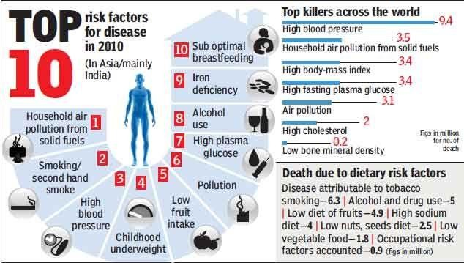

(Source: <http://urbanemissions.blogspot.in/2013_03_01_archive.html)>

# Figure 1.2 Picture depicting the top 10 risk factors for disease in 2010 in Asia (mainly India)

It is very clear from Figure 1.2 that outdoor air pollution has become India’s fifth highest killer, only after high blood pressure, indoor air pollution, high body mass index and diets that are poor in fruit and vegetables.

The most vulnerable to air pollution are children, the elderly and people already suffering from respiratory or cardiac ailments, says *Anumita Roychowdhury*, an air pollution expert at the Delhi-based nonprofit Center for Science and Environment (CSE). Even healthy adults in the prime of their lives are at risk. The dangers range from cancer to hypertension, diabetes and birth defects. “We need to be extremely careful,” says *Roychowdhury*. There are 7,12,000 deaths per year due to air pollution in South Asia including India (Muthukumara 2013).

# Air Pollution related Episodes and Accidents

There were significant incidents of air pollution episodes and accidents happen in the past in different parts of the world. They had drawn very much attention of people towards air pollution and their adverse effects. Thus, it is important to look at those incidents in order to have better idea to take care in the future. They are compiled in the Table 1.3.

12

# Table 1.3 Air Pollution related Episodes and Accidents

|  |  |  |  |
| --- | --- | --- | --- |
| Place of incident | Year | Duration/ Cause | Adverse Effect |
| Meuse Valley, Belgium | 1930 | 3 day fog | 60 people died |
| Manchester, England | 1931 | 9 day fog | 592 people died |
| Donora, Pennsylvania, USA | 1948 | 4 day fog | 7000 people were reported sick and 20 people died |
| London, England | 1952 | 4 day fog | 4000 deaths (concentrations were several times higher than the current air quality standards) |
| Three Mile Island, USA | 1979 | Nuclide Emissions, within permissible limits. (accidental shutdown of nuclear reactor) | No deaths. The only palpable effect was psychological stress during and shortly after the accident. |
| Bhopal, India | 1984 | 4 hours accidental release of methyl isocyanate at a chemical plant | Killed 2800 people by causing Pulmonary edema and Respiratory infections such as bronchitis and bronchial pneumonia and more than 170,000 survivors had adverse  health effects and reproductive adverse effects |

13

|  |  |  |  |
| --- | --- | --- | --- |
|  |  |  | (Leucorrhea, pelvic inflammatory disease, excessive menstrual bleeding, and suppression of lactation and also stillbirths and spontaneous abortions). |
| Chernobyl, Russia | 1986 | Release of nuclide emissions. (nuclear reactor accident due to improper operation) | 32 deaths and 135,000 people and their livestock had to be removed from the region for several months. The radiation exposure could increase the cancer death rates in USSR and Europe in coming years. The agricultural activities near the plant have been halted. |
| Fukushima, Japan | 2011 | Nuclide Emissions. (nuclear reactor accident following a major earthquake) | No deaths or cases of radiation sickness. Over 100,000 people were evacuated from their homes to ensure safety. |

(Sources: <http://www.eng.utoledo.edu/~akumar/IAP1/introduction.htm>and [http://www.](http://www/) world-nuclear.org/info/Safety-and-Security/Safety-of- Plants/Safety-of-Nuclear-Power-Reactors/)

# Contributors of Air Pollution in Urban Areas

Transport is the major economic activity that accounts for a bulk of the air pollution in urban areas. Transport and energy sectors are considered to be the major air polluters. Road transport sector causes more urban airborne pollution than any other single human activity (Noman 2002).

Quest for growth (in terms of industry, power generation & transportation) plays a key role in the development process of a country but ultimately deteriorates surrounding environmental conditions. Most of the cities in developed and developing countries have become major “environmental hot spots” that urgently require special attention for studies and proper environmental and transport planning /and traffic management for air pollution and wastes management, ecological sustainability and pollution controls. The man-made causes of air pollution (in %) by various activities in urban centers are shown in the Figure 1.3.

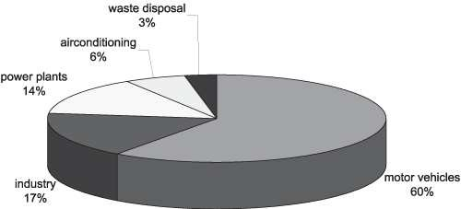

(Source: HaileeZiehr. ‘OBRIEN-envproject, man made vs. natural air pollution.’)

# Figure 1.3 Picture showing the contributors of air pollution in percentage in urban areas

* 1. India’s Air Pollution Monitoring System

## *National Air Quality Monitoring Programme (NAMP)*

Central Pollution Control Board (CPCB) of India is a statutory organisation under the Ministry of Environment and Forests (MoEF) established under Water (Prevention and Control of Pollution) Act in 1974. CPCB is also entrusted with relevant powers and functions under the Air (Prevention and Control of Pollution) Act, 1981. It serves as a field formation and also provides technical services to the Ministry of Environment and Forests of the provisions of the Environment (Protection) Act, 1986. It Co-ordinate the activities of the State Pollution Control Boards by providing technical assistance and guidance and resolve disputes among them. It is an apex organization in the country in the field of pollution control, as technical wing of MoEF (CPCB 2014).

CPCB in collaboration with the State Pollution Control Boards (SPCBs) has established a National Ambient Air Quality Monitoring (NAMP) network under the Air (Prevention and Control of pollution) Act, 1981 to collect, compile and disseminate information on air quality. The Ambient air quality is monitored by CPCB, SPCBs, National Environmental Engineering Research Institute (NEERI), Pollution Control Committees, some Universities and Institutes to ascertain the characteristics and concentration of pollutants in the ambient air whether man-made or natural. The data thus generated are transmitted to CPCB for scrutiny, analysis, compilation and publications as a consolidated report.

Monitoring of air pollution helps taking necessary preventive and control measures. CPCB co-ordinates NAMP to ensure uniformity, consistency of air quality data and provides technical and financial support for operating the

monitoring stations. Since large number of personnel and equipment are involved in the sampling, chemical analyses, data reporting etc., it increases the probability of variation and personnel biases reflecting in the data; Hence, it is pertinent to mention that these data be treated as indicative rather than absolute.

As on date, there are 573 operating stations in 240 cities/towns in 26 states and 5 Union Territories of the country. The number of operating stations state-wise and city-wise is given in *Appendix 3*. Under NAMP, four criteria air pollutants viz., Sulphur Dioxide (SO2), Nitrogen dioxides (NO2), Suspended Particulate Matter (SPM) and Respirable Suspended Particulate Matter (RSPM/PM10) have been identified for regular monitoring at all the locations. The monitoring of pollutants is carried out for 24 hours (4-hourly sampling for gaseous pollutants and 8-hourly sampling for particulate matter) with a frequency of twice a week, to have 104 observations in a year (CPCB 2014). The monitoring of meteorological parameters such as wind speed and direction, relative humidity and temperature were also integrated with the monitoring of air quality at few monitoring stations.

## *Air Quality Monitoring in Chennai under NAMP*

There are 11 monitoring stations (10 conventional stations and 1 on-line monitoring station) in Chennai as mentioned in *Appendix 3*. At all monitoring stations (except the on-line one), samples are collected and tested using analytical procedures which process is very laborious and time consuming. So, this method requires continuous 24 hours sampling using High Volume Sampler and further it is necessary to take samples to laboratory for testing and analysis.

*Appendix 3* mentions the disclosure by the Central Pollution Control Board of existence of 11 monitoring stations in Chennai. As per the air

pollution report published by the Tamil Nadu Pollution Control Board in their website (tnpcb.gov.in), 5 monitoring stations have been in operation from the year 2007 to 2013 and 5 proposed sites are under construction and one is an on- line monitoring system at head office, Guindy, Chennai.

# Need for the Research

WHO observed that India ranks among the world’s worst for its polluted air. Out of the 20 most polluted cities in the world, 13 are in India. *Sunita Narain*, Director General, Centre for Science and Environment (CSE) states: “This database confirms our worst fears about how hazardous air pollution is in our region. Last year, the Global Burden of Disease study pinned outdoor *air pollution* as the *5th largest killer in India* after high blood pressure, indoor air pollution, tobacco smoking, and poor nutrition; about 620,000 early deaths occurred in India from air pollution-related diseases in 2010.”

*Sunita Narain* also points out that, 18 million years of healthy lives are lost due to illness burden that enhances the economic cost of pollution. Half of these deaths have been caused by ischemic heart disease triggered by exposure to air pollution and the rest due to stroke, chronic obstructive pulmonary disease, lower respiratory track infection and lung cancer.

There are reports published in daily newspapers about the adverse effects of air pollution in Chennai. For example, as per the report published by Janani Sampth on November 20, 2013 in The Times of India titled ‘Chronic respiratory illness cases rise with air pollution,” *Dr G S Vijayachandar* (Pulmonologist at the Institute of Thoracic Medicine) reports that 200 of 300 patients suffer from blockages in the airway tract due to air pollution.

As per the report published on August 16, 2014 in the Deccan Chronicle titled “*Chennai city pollution affecting kids most*,” “*Respiratory physicians in the city* said that, they are now-a-days seeing more school-going children with complaints of persistent cough and cold. Often misdiagnosed and given antibiotics, these children end up becoming asthmatics.” Further, Physicians say that “they see many parents accompanying kids with recurring episodes of wheezing, breathlessness and coughing. A school kid travels at least six km from home to school and they are exposed to vehicle emission and air pollution.”

As per the report published in The Times of India titled “*Chennai breathless as more vehicles add to pollution*” on June 2, 2013, the rapid increase in vehicle population in the city has led to ENT and pulmonology clinics seeing a surge in cases of respiratory illnesses caused due to severe air pollution. The allergy and pulmonology clinic at the Madras ENT Research Foundation (MERF), which registered 823 cases of respiratory illnesses in

2011, saw more than 1,472 cases last year with asthma and Chronic Obstructive Pulmonary Disease (COPD) topping the list.

"With its humid weather acting as a trigger, Chennai seems to choke with respiratory issues and the situation will ease only when the pollution levels come down," says, Dr Mohan Kameswaran, Managing Director, MERF (The Times of India 2013). He says 90% of the patients coming to the clinic suffered from dust allergy that stemmed from environmental pollution. "Earlier, only adults had such problems. Now, even children are suffering. Patients who come in with wheezing, nasal bleeding and inflammation where there is a block in the airway, is seen all the result of inhaling soot and carbon particles emitted by vehicles," he says.

At present, scientific understanding of air pollution is not sufficient for accurate prediction of air quality at all times throughout the country. Many more sampling stations are required to cover large areas in cities. The setting up of monitoring stations with conventional equipments for sampling at any location in the urban areas is very costly due to space constraint and exorbitant cost of land. In addition to this, samples have to be taken to laboratories for analytical procedure to find concentrations of pollutants which is laborious and time consuming work although the readings obtained are accurate to the great extent. The recent technology of real time mobile monitoring using solid state gas sensors is compact and cheaper and it helps in monitoring of air pollutants at many places in a short time as compared to conventional stationary monitoring. By using this method, air quality in a large area will be obtained at low cost (Peter et al 2008). The monitored data can be transmitted to Internet in real time for the benefit of public and also to enable the concern authorities to take necessary steps in mitigation of air pollution.

Therefore, real time mobile monitoring can be used for observing pollution levels at many places enhancing the coverage area. It provides regular measurements of air pollutant concentration throughout the city with ease and low cost, which can then be analysed and interpreted. Analysis of monitoring data allows us to assess the impact of air pollution in day to day situations.

At present, CMA has a limited number of six static monitoring stations. The air quality measured at these six locations might not adequately represent true air quality as the CMA has area of about 1189 sq.km. Hence, there is an imperative need for mobile monitoring of air quality in order to cover a large area and the pollution data can be made available in real time for public and decision makers to take necessary steps for control and mitigation measures.

**CHAPTER 2**

**LITERATURE REVIEW**

# Introduction

Any activity involving burning things/fuels and mixing substances that cause chemical reactions may release toxic gases in the process and some activities like construction, mining, transportation, etc. produce large amounts of dust which has the potential to cause air pollution.

There are about a half billion cars on the road today. Virtually all of them are powered by gasoline and diesel engines that burn petroleum to release energy. Petroleum is made up of hydrocarbons (large molecules built from hydrogen and carbon) and, in theory, burning them fully with enough oxygen produces nothing worse than carbon dioxide and water.

In practice, fuels are not pure hydrocarbons and engines do not burn them cleanly. As a result, exhausts from engines contain all kinds of pollution, notably particulates (soot of various sizes), carbon monoxide (CO), a poisonous gas), nitrogen oxides (NOx), volatile organic compounds (VOCs), and Lead (Pb) and indirectly produced ozone. Mixing up these noxious gases together and energizing it with sunlight produces sometimes brownish, sometimes bluish fog of pollution called smog, which can hang over cities for many days (Chris Woodford 2014).

Air Pollution renders air unfit for respiration by humans and animals. Air pollution problem has been aggravated by the tremendous increase in the number of mobile sources (motor vehicles) in urban areas. The latest available

data on air quality have prompted WHO to call for greater awareness of health risks caused by air pollution, implementation of effective air pollution mitigation policies and close monitoring of the situation in cities worldwide.

In April 2014, WHO issued new information after estimating that outdoor air pollution was responsible for the deaths of about 3.7 million people under the age of 60 in 2012 (TNI 2014). Figures 2.1 and 2.2 illustrate the deaths attributable to ambient air pollution in 2012, by disease, age and sex respectively (WHO-PHE 2014).

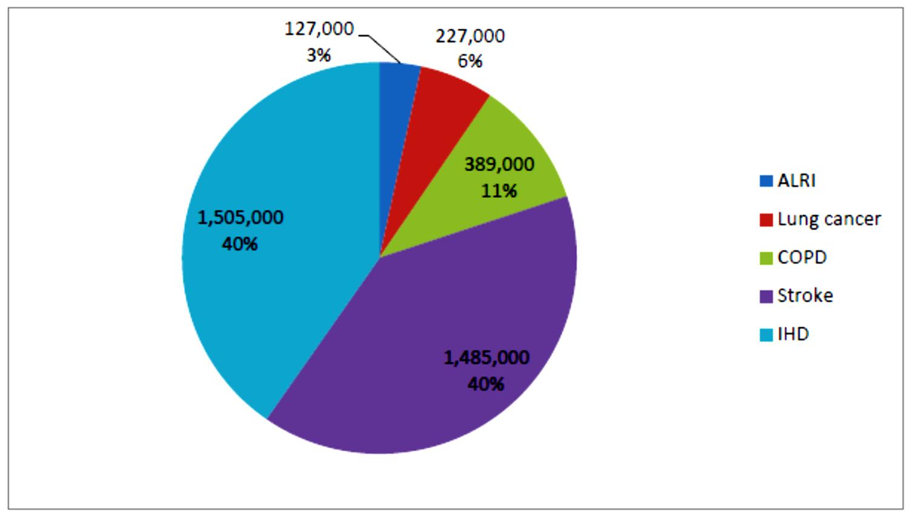

Figure 2.1 Picture depicting the deaths attributable to ambient air pollution in 2012, by disease. (ALRI: Acute lower respiratory disease; COPD: Chronic obstructive pulmonary disease; IHD: Ischaemic heart disease).

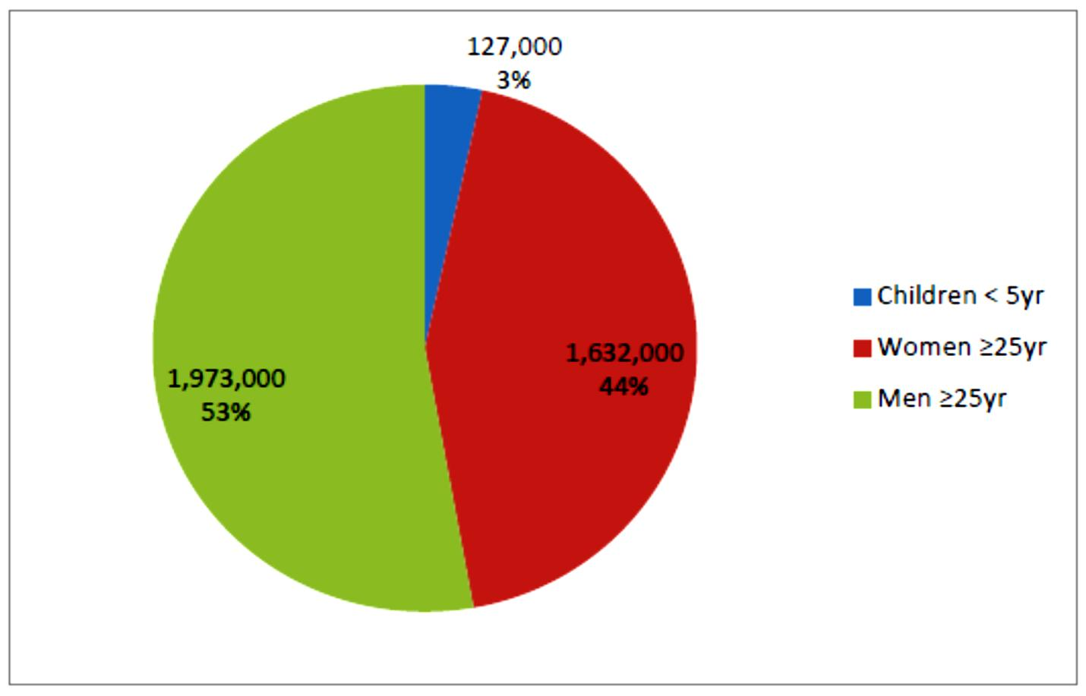

# Figure 2.2 Picture depicting the deaths attributable to ambient air pollution in 2012, by age and sex.

* 1. Air Quality Index

United States Environmental Protection Agency designated a standardized air pollution level indicator known as the *Air Quality Index* (AQI), which mainly consists of six common air pollutants called as *criteria air pollutants* that can injure health, harm the environment and cause property damage are carbon monoxide (CO), Lead (Pb), nitrogen dioxide (NO2), Ozone (O3), particulate matter (PM), and sulfur dioxide (SO2) (USEPA-APM).

In India, the Central Pollution Control Board (CPCB) has specified CO, NO2, SO2 and PM as criteria pollutants for monitoring through its National Air Quality Monitoring Programme (NAMP). The United States’ AQI category with AQI rating for four criteria pollutants has been given in the Table 1.1 (Mahboob et al 2008).

# Vehicles’ Contribution of Air Pollution in Urban Centers

Vehicles constitute a major source of pollutants in metropolitan cities. Air pollutants such as CO, NOx, SPM and HC are emitted from motor vehicles into the atmosphere in significant quantities in addition to CO2 emission, causing serious environmental and health problems. Health problems due to air pollution have assumed serious proportions in major metropolitan cities and other urban parts of India and vehicular emissions have been identified among the major contributors in the deteriorating air quality in these urban centers (CPCB 1999).

Increase in air pollution levels in urban centers of the world is closely identified with increase in the number of motor vehicles (Mage et al 1996; Mayer 1999). Air pollution from motor vehicles is one of the most serious and rapidly growing problems in urban centers of India, like in any other urban parts of the world (UNEP-WHO 1992; CRRI 1998).

In Delhi, the daily pollution load has increased from 1,450 tonnes in 1991 to 3,000 metric tonnes in 1997 (MoEF 1997). The share of the transport sector has increased from 64% to 67% during the same period while that of the industrial sector (including power plants) has been decreased from 29% to 25% (MoEF 1997).

Another study carried out in Delhi shows the contribution of industrial (including thermal power plants), vehicular and domestic sources of pollution to the ambient air in Delhi is shown in Table 2.1 during the periods 1970-71 to 2000-01.

# Table 2.1 Contribution of air pollution from various sources in Delhi in percentage during the periods 1970-71 to 2000-01

|  |  |  |  |  |
| --- | --- | --- | --- | --- |
| Source | 1970-71 | 1980-81 | 1990-91 | 2000-01  (Projected) |
| Industrial | 56% | 40% | 29% | 20% |
| Vehicular | 23% | 42% | 64% | 72% |
| Domestic | 21% | 18% | 7% | 8% |

(Source: MoEF, 1997; CPCB, 2003)

Table 2.1 clearly indicates the percentage decrease in air pollution due to industries and domestic sector as compared to percentage increase due to vehicular air pollution over a period of 4 decades. It is also an indication of the palpable increase in use of motor vehicles in urban areas.

The contributors of air pollution at Delhi and Chennai indicated in Figure 2.3 which clearly shows that the transportation sector causes about 70% of the air pollution in metropolitan cities, presently.

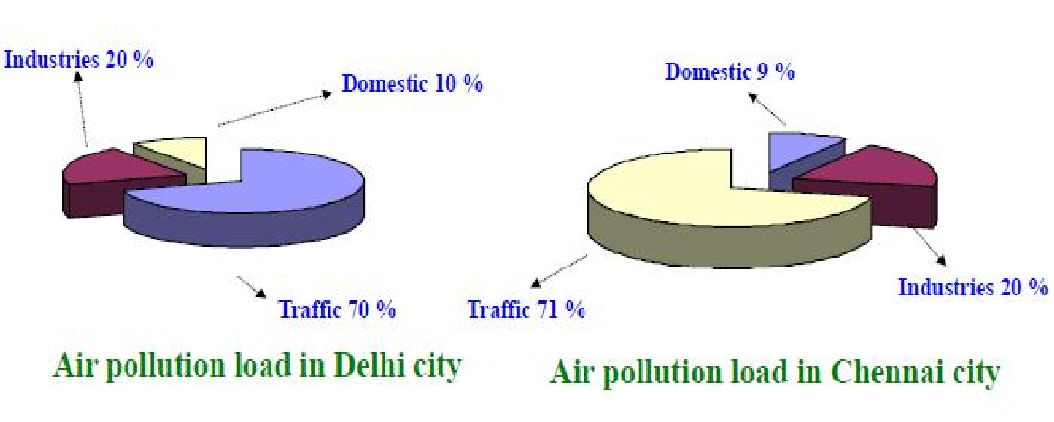

(Source: Urban Air Quality Management @ TNPCB, 2013)

# Figure 2.3 Picture shows the contributors of air pollution in two of the metropolitan cities of India: Delhi and Chennai

* 1. Review on use of Solid State Gas Sensors for Air Quality Monitoring System

In general, commercial sensors have application in a variety of fields such as environmental engineering, indoor climate control and ventilation control, medicine diagnostics and breath analysis in medicine, structural monitoring, surveillance, disaster management, emergency response, gasoline vapour detection in automobiles, leak detection and fire detection in safety, food process control and fermentation control in food and other industrial productions. Sensors integrated with Wireless Sensor Networks (WSN) facilitate monitoring and controlling of physical environments from remote locations with better accuracy.

Duk-Dong Lee and Dae-Sik Lee (2001) state that natural atmospheric environment has become polluted and is rapidly deteriorating due to the dramatic growth in industrial development and urbanisation. Thus, monitoring and control of such pollutants is imperative for prevention of environmental disasters. Use of conventional analytical instruments for monitoring purpose is time consuming, expensive and seldom used in real-time in the field. An effective alternative is use of solid state gas sensors that are compact, robust with versatile applications and low cost. They have also presented comparison between analytical instruments and briefed about the various solid state gas sensors namely semiconducting type, capacitor type and electrolyte types sensors.

Simon et al (2001); Semancik et al (2001) have reviewed gas sensors and summarized that semiconductor gas sensors known also as chemo-resistive gas sensors are typically based on metal oxides (e.g. SnO2, TiO2, In2O3, WO3, NiO, etc.). They conclude that the applied studies of recent findings and products have shown some significant trends on nanotechnologies and gas-

sensing layers to be employed. One of these trends aims to implement low cost, low-power consumption, reliable, smart and miniaturized sensing devices and it shows the decisive advantage of using micro-machined silicon platform as substrates for the sensitive layers. According to them, the gas sensors can be improved in different ways by use of filters (Park et al 2002), catalysts and promoters or more specific surface additives (Vlachos et al 1997), selection of the material for the sensing layer (Moseley 1992) and its physical preparation, analysis of the transient sensor response (Distante et al 2002), selection of a fixed temperature to maximize sensitivity to a particular analyte gas (Capone 2001) or by use of temperature modulated operation mode (Andrew 1999).

Capone et al (2003) are of the opinion that the demand for gas detection and monitoring has grown following awareness about the need to protect the environment. According to them, the solid state gas sensors based on a variety of principles and materials, are the best choice for this purpose. They also say that the great interest shown by industrial and scientific world on solid state gas sensors is due their numerous advantages, like small sizes, high sensitiveness in detecting very low concentrations (at level of ppm or even ppb) of a wide range of gaseous chemical compounds, possibility of on-line operation and due to possible low cost bench production.

Kawasaki et al (2004); West et al (2005) have classified sensors into semiconducting type, solid electrolyte type, electrochemical type and catalytic combustion type. According to them, the sensors have the advantages of rapid reactivity, high efficiency, and gas selectivity when suitable additives are applied to it. Ceramics are most commonly used for making sensors, as they are the most reliable materials in very severe conditions like high temperature, reactive or corrosive atmosphere and high humidity. The gas-sensing materials for semiconductor type are SnO2, WO3, In2O3, perovskite-structure oxides, etc., and the electrolyte for solid electrolyte-type gas sensor is Na3Zr2Si2PO12.

Sensing properties (mainly sensitivity and selectivity) as well as stability over time of the oxide layer can be improved by reducing the metal oxide grain size down to nanometer scale (Xu et al 1991; Gurlo et al 1998). Nanocrystalline semiconducting metal oxides with controlled composition are indeed of increasing interest in gas sensing and constitute also a new and exciting subject of fundamental research (Barsan et al 1999).

Korotcenkov (2007) has focused on the conductometric semiconducting metal oxide gas sensors (especially surface conductive metal oxide). According to the author, they constitute currently one of the most investigated groups of gas sensors. They have attracted much attention in the field of gas sensing under atmospheric conditions due to their low cost and flexibility in production, simplicity of their use and possibility of many application fields and the large number of detectable gases. In addition to the conductivity change of gas-sensing material, the detection of this reaction can be done by measuring the change of capacitance, work function, mass, optical characteristics or reaction energy released by the gas/solid interaction. As per the author’s review, there are numerous researchers who have shown that the reversible interaction of the gas with the surface of the material is a characteristic of conductometric semiconducting metal oxide gas sensors.

Chengxiang et al (2010) have reviewed sensitivity and influencing factors of Metal Oxide Gas Sensors. They have come to the conclusion that the sensitivity of the metal oxide based materials changes with the factors influencing the surface reactions, such as (i) chemical components, (ii) surface- modification, (iii) microstructures of sensing layers, (iv) temperature and (v) humidity.

In their brief review, the study is focused on changes of sensitivity of conductometric semiconducting metal oxide gas sensors due to the five factors

mentioned above. As the authors brief further, the surface reactions can be influenced by many factors, including internal and external causes, such as natural properties of base materials, surface areas and microstructure of sensing layers, surface additives, temperature and humidity, etc. One of the important parameters of gas sensors is sensitivity that has been attracting increasing attention and much effort has been made to enhance the sensitivity of gas sensors. There is no uniform definition of gas sensor sensitivity as of now. Usually, sensitivity (S) can be defined as Ra/Rg for reducing gases or Rg/Ra for oxidizing gases, where Ra stands for the resistance of gas sensors in the reference gas (usually the air) and Rg stands for the resistance in the reference gas containing target gases. Both Ra and Rg have a significant relationship with the surface reaction(s) taking place.

Kwang (2011) says that air pollution caused by exhaust gases from automobiles has become a critical issue. The principal gases that cause air pollution from automobiles are nitrogen oxides, NOx (NO and NO2) and carbon monoxide (CO). He has defined gas sensor as a device that can substitute for human olfaction, and that converts a physical phenomenon into an electrical signal. According to him many researches are being conducted to monitor air pollution by using these gas sensors, the first decade of the 21st century has been labeled by some as the “Sensor Decade.” Sensors can be interfaced between the physical world and the world of electrical devices, such as computers.

Emily et al (2013) observe that historical approaches for monitoring air pollution generally use expensive, complex, stationary equipments (Chow 1995; Fehsenfeld et al 2004) that work based on the techniques MS, GC, FTIR, etc limit data collection and access to the data. This paradigm is changing with the materialization of lower-cost, easy-to-use and portable air pollution monitors (sensors) that provide high-time resolution data in near real-

time. These attributes provide opportunities for enhancement of the range of existing air pollution monitoring capabilities and perhaps provide avenues to new air monitoring applications.

Sensors associated with to advances in computing and communication also provide enhanced availability and accessibility of air monitoring data. Sensor devices are currently available for monitoring a range of air pollutants and new devices are continually being introduced (White 2012). Meanwhile, the emergence of information on the high spatial variability of primary air pollutants (Seinfeld et al 1998; Solomon et al 2008; Baldauf et al 2008; Clements et al 2009; Olson et al 2009; Sioutas et al 2005; Venkatram et al 2009) and per capita increase in asthma or other health conditions sensitive to air pollution (Solomon et al 2012) motivates finer-grained and more personalized air monitoring data collection. Indeed, the attraction towards lower cost sensors is so great that widespread data collection and data sharing using new sensors are already occurring even before sensor performance has been characterized ([http://airqualityegg.com/).](http://airqualityegg.com/)) However, challenges remain, regarding the use of sensors and sensor data, chiefly sensor data quality and derivation of meaningful information from data sets.

However, recent advances in nano-technology have facilitated synthesis of materials with new properties by means of the controlled manipulation of their microstructure on a nanometer scale, enhanced the gas sensing properties thereby increasing the performance of solid state gas sensors.

# Review on Real Time Mobile Air Quality Monitoring Using Solid State Gas Sensors

With improvements in technology, many air pollution systems have been designed and developed using solid state gas sensors in various areas for monitoring air pollution. The sensors in combination with WSN technology will greatly enhance monitoring of the natural environment and in some cases open up new technology for taking measurements or allow deployments of sensors in those places considered impossible earlier. With the rapid development of micro-electromechanical systems and WSN technology, it is possible to create cost effective & low power air quality monitoring systems. The integration of an air pollutant monitoring system with WSN technology will reduce installation costs and enable the quick and easy reconfiguration of the data acquisition and control systems. These were reported in the recent literature which is compiled hereunder.

Pummakarnchana et al (2005) are of the opinion that economic growth and industrialization are proceeding at a rapid pace, accompanied by increasing emissions of air polluting sources. They emphasize on the urgent need for suitable monitoring systems to ensure rapid detection of air pollution levels and for reliable quantification of polluting sources in order to prevent further deterioration in polluting levels.

The Authors state that a new generation of detectors, solid state gas sensors, offer excellent alternatives for environmental monitoring due to low cost, light weight, extremely small size and also due to the reason that they can be deployed anywhere so as to receive data that can eventually be transmitted through a Wireless GIS network system as a rapid monitoring tool to the general public. In their research work, they have designed and developed a portable device, comprising solid state gas sensor (NOx) integrated to a

Personal Digital Assistant (PDA) linked through Bluetooth communication tools and Global Positioning System (GPS) for rapid dissemination of information on pollution levels at multiple sites simultaneously. They have established air sampling points using solid state gas sensors at the same locations as the air quality monitoring sites of the Pollution Control Department (PCD) in Bangkok, in addition to the other places to compare the NOx concentration values acquired from the solid state gas sensor devices and the PCD’s air quality monitoring system. They have carried out air pollution monitoring over extensive areas in Bangkok, Thailand and suggested that the Air Quality report generated can be published using Internet GIS to provide a real-time information service for the PCD, for increased public awareness and enhanced public participation. They also suggest the use of local deterministic and geo-statistical interpolation methods used for spatial prediction, based on observations at each monitoring site.

Abujayyab et al (2006) have proposed an abstract model of a system which is based on long-range wireless communication for air pollution monitoring. In another study, Kwon et al (2007) have developed an outdoor air pollution monitoring system using ZigBee networks with a wireless sensor board in which dust, CO2, temperature, and humidity sensors are employed. Its monitoring range is 270 m. It is used for monitoring air quality at a fixed location. Jung et al (2008) have installed an air pollution geo-sensor network consisting of sensors and routers at various locations to monitor several air pollutants. Tsow et al (2009) have developed a wireless sensor system for real- time monitoring of toxic environmental Volatile Organic Compounds (VOCs) based on a smart sensor micro converter equipped with a network capable application processor that downloads the pollutant level to a personal computer for further processing.

Tajne et al (2011) stated that conventional air quality monitoring approaches are limited with respect to time, expense, and installation sites. Therefore, only limited data is available for the estimation of ambient air toxins. Further, air quality monitoring systems built using conventional equipments (MS, GC, FTIR) have spatial and temporal limitations, due to manual conduct of measurements. According to the authors, the Wireless Sensor Network (WSN) is a fast evolving technology with a number of potential applications in various domains of daily life, such as structural and environmental monitoring, medicine, military surveillance, condition based maintenance etc. A WSN is composed of a large number of sensor nodes that are usually deployed either inside a region of interest or very close to it. WSN nodes are low power embedded devices consisting of processing and storage components (a processor connected to a RAM and/or flash memory) combined with wireless RF transceiver and some sensors/actuators.

In their study, they have proposed air pollution monitoring & control system comprises of sensor nodes consisting of sensors and microprocessor and a communications system-WSN which has been named as Mica2 mote, which allows the data to reach a server. The sensor nodes gather data autonomously and the data network is used to pass data to one or more base stations that shall forward it to a sensor network server.

The authors have illustrated a method of controlling the air pollution as shown in Figure 2.4, which is that people can avoid polluted areas shown by pollution sign board with the red color and can choose to travel in other paths. Travelling in less polluted areas by knowing the pollution information through the display system at each sensor node can prevent further increase in pollution at highly polluted areas.

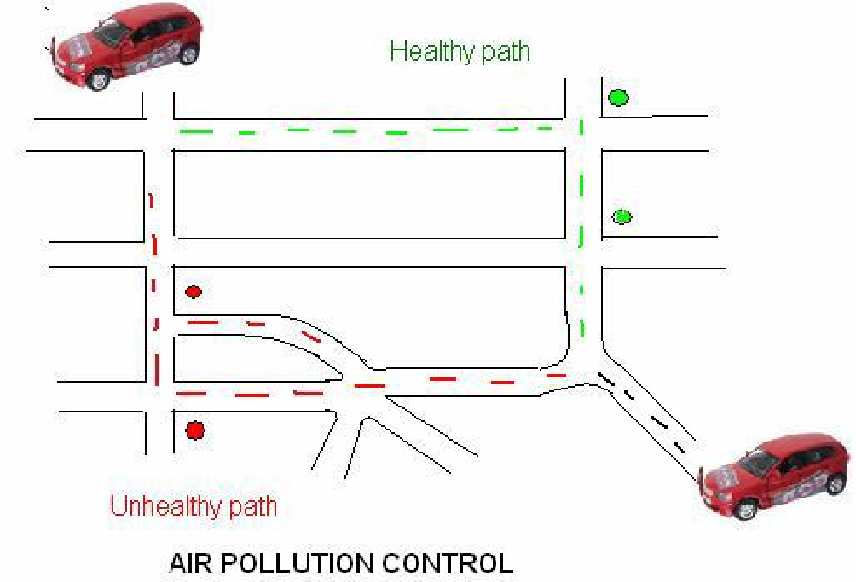

# Figure 2.4 Picture shows one of the methods of air pollution control by the way of real time air pollution monitoring

They have also simulated the sensors nodes in combination with WSN technology and have drawn the following conclusions; (i) Recent technological developments in the miniaturization of electronics and wireless communication technology have led to the emergence of Environmental Sensor Networks. (ii) The Environmental Senor Networks will greatly enhance monitoring of the natural environment and in some cases open up new techniques for taking measurements or allow previously impossible deployments of sensors. (iii) WSN technology for air pollution and monitoring will be very beneficial for monitoring different high risk regions of the country and (iv) WSN technology can provide real time information about the level of air pollution in these regions, as well as provide alerts in cases of drastic change in quality of air. The information provided can help the authorities to take prompt actions such as evacuating people or sending emergency response teams. Thus WSN networks can be used effectively for monitoring air pollution in the areas where regular monitoring is needed.

Raja et al (2011) have attempted development of an effective solution for pollution monitoring using wireless sensor networks (WSN) on a real time basis, namely, real time wireless air pollution monitoring system using commercially available discrete pre-calibrated gas sensors for sensing concentration of gases like CO2, NO2, CO and O2. These gas sensors were integrated with the wireless sensor motes/modules for field deployment at the Indian Institute of Technology, Hyderabad campus and the Hyderabad city using multi hop data aggregation algorithm. A light weight middleware and a web interface to view the live pollution data in the form of numbers and charts from the test beds were developed.

The authors have used Libelium Wasp motes as basic wireless communication modules and the sensor boards with different gas sensors which comprise a communication unit and a processing unit respectively that are shown in Figure 2.5.

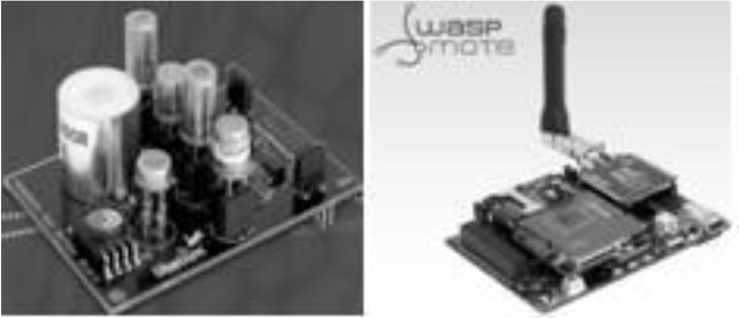

# Figure 2.5 Sensor board with different gas sensors (processing unit) and Libelium Wasp mote (communication unit)

Analog to Digital Converter (ADC) ports of the wireless nodes are programmed to periodically sample the various gas sensors interfaced to the sensor board on a rotational basis. The collected samples are packetized and

sent to base station (Sung-Hwa et al 2007; Gongbo et al 2009) at regular intervals from each of the sensor nodes, which forms the mesh network. Figure

* 1. shows the sensor nodes and the communication network system.

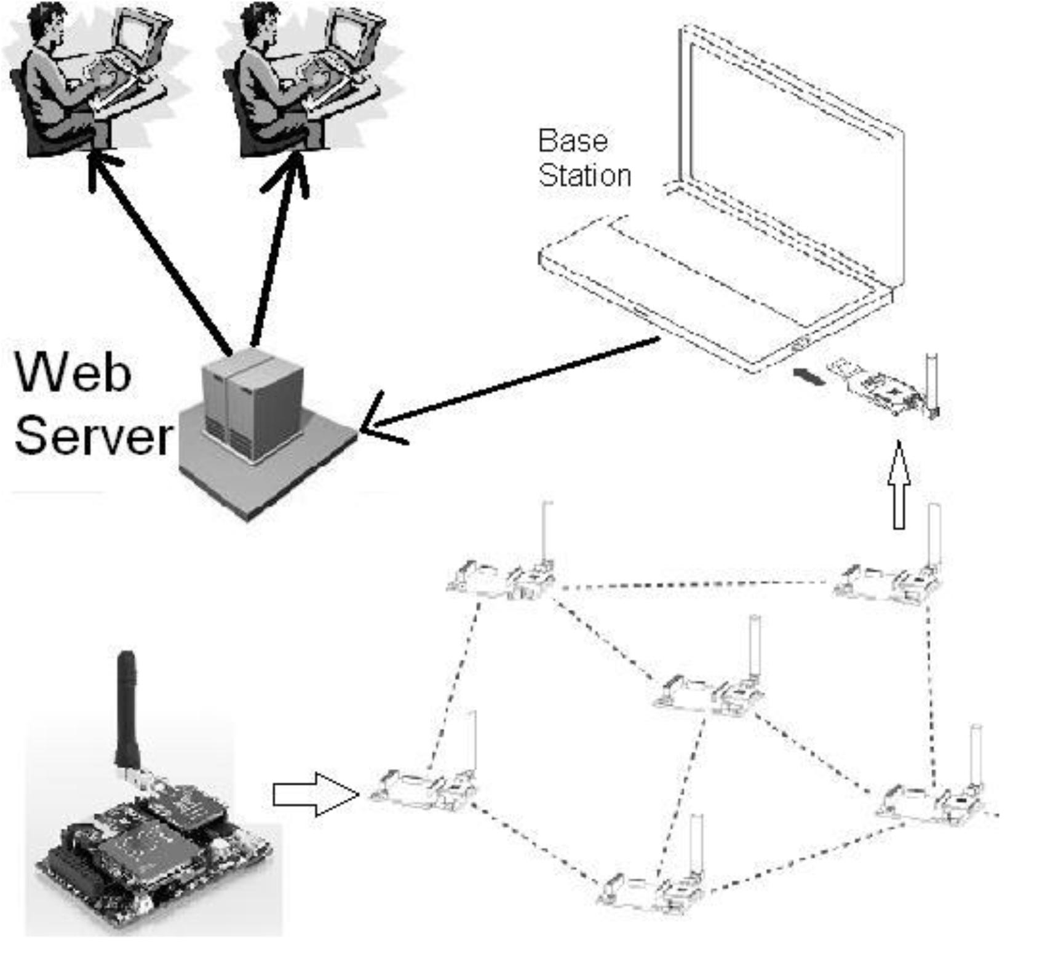

# Figure 2.6 Multihop mesh network system architecture for the real time wireless pollution monitoring system.

In order to increase the monitoring range, a multi hop data aggregation algorithm (Mohd and Sarijari 2008) has been implemented. The authors have followed a Wasp mote technical guide to configure RF Xbee module, gain of signal conditioning and other modules on the WASP system (Wasp mote technical guide). In this way the authors have developed and deployed real time

pollution monitoring with five node networks to test and obtain the reliable data from the experimentation under different physical conditions.

Dan et al (2011) have proposed an environmental air pollution monitoring system that measures CO2, NO2, CO, HC & NH3 concentration using mobile sensors in urban environment. They have designed, tested and built a reliable measurement device that can acquire information about the air quality of its surroundings. In this system the acquired information about air pollution in surroundings is stored in a temporary memory buffer and periodically relay it to a central on-line repository. It uses a wireless GSM modem connection for transferring data to a central computer and can be freely accessed by the public through on on-line web interface. Users can select and view different gases and its concentrations overlapped on a map of the city.

Vikhyat (2013) had come up with a proposal environmental monitoring system called *ArduAir* which is a small and portable measurement system which includes various gas sensors (such as CO, CO2, NO2, O3, etc.) and microcontroller that can be used by a number of persons simultaneously. He has proposed a software for collecting data from the *ArduAir* and plotting it in real-time which will provide the user with (i) Low-cost and low-power measurement hardware that is suitable for mobile measurement, (ii) User- friendly data collection and processing software, (iii) Gathering high quality data and (iv) Easy to use instrument that can be used commercially by a large number of people.

The author has, for sample purposes connected one CO sensor to a module called an Arduino microcontroller which is then connected to a computer through a serial communication. The data collected by the arduino microcontroller from the sensor is then sent to the computer software where it gets recorded and plotted in real-time. In this way the ArduAir is designed and

built in a small size, portable and low-cost air pollution monitoring system to monitor CO. The author has suggested that this sensor based system can also be used for various other gases such as SO2, NO2, CO2, O3, etc. using different sensors. This system can thus be utilized effectively by the general public for monitoring the quality of air around them.

It is learnt from the literature review that mobile monitoring device can be designed and developed using solid state gas sensors and simultaneously information on the observed air pollution information can be disseminated in real time. Vehicular emission consists mostly of carbon dioxide (CO2), carbon monoxide (CO) and nitrogen oxides (NOx). Hence, it is proposed to carry out air pollution study in the Chennai Metropolitan Area using the air quality monitoring device (AQMD), connected with inputs such as GPS receiver for identification of location (latitude and longitude, date and time) and three gas sensors CO2, CO and NO.

CHAPTER 3

OBJECTIVES

The objectives of this research work are to design, as well assemble and test a dynamic system that can detect the presence of natural and combustible gases and send an SMS alert to the user and nearest disaster management if gas leakage occurs. The dynamic system makes mainly the use of Wireless Sensor Network (WSN).

The objectives of this research work are as follows;

* To design and develop a real time mobile monitoring device for air quality measurements using low cost solid state gas sensors (CO, CO2, NO), Global Positioning System (GPS), Personal Computer and GSM Module.
* To study the air pollution levels in Chennai Metropolitan Area (CMA) using the Air Quality Monitoring Device (AQMD).

To suggest air pollution prevention and control measures in case of air pollution levels exceeding the norms of CPCB

Chapter 1 of this thesis is the Introduction dealing with the meaning of air pollution, its causes and its adverse affects. The major air pollution related episodes and accidents occurred all over the world are tabulated in chronological order in the Table 1.3. The major contributors of air pollution in urban areas, India’s air pollution monitoring system (NAMP) and that of it at Chennai in particular, objectives and need for the research has been presented.

In chapter 2 the work done in this area has been reviewed including environmental sensors and air quality monitoring devices using these sensors and wireless technology. In the chapter 3, the area under study, about the details of CMA have been described including its demographic details, geography, climate, economy and vehicular growth in general and also recent health problems due to air pollution published in the news papers have been presented at the end of the chapter.

Chapter 4 deals with the design and development of Air Quality Monitoring Device (AQMD) including details about different types of sensors used in the device, GPS module, single chip microcontroller - ARM7 processor, GSM module and software architecture used.

Chapter 5 provides details of air pollution data collection by static monitoring and mobile monitoring carried out using AQMD in the CMA area. Chapter 6 consists of results and discussions on air pollution data that is collected and presented in the chapter 5.

**CHAPTER 4:**

**ARCHITECTURE**

# **4.1 The Wireless Sensor Network**

A Wireless Sensor Network is defined as the systematically distributed organization of the Smart Sensor Nodes (SN) of an embedded philosophy, wirelessly routed among themselves and also to the Base Station (BS) through well featured networking protocol, working under the standards of IEEE 802.15.4. It is a network of self powered devices, known as sensor nodes or Motes*,* which can sense physicochemical parameters and cooperatively communicate the sensed information from actual process field, through wireless links [115]. Further, such sensed information can be forwarded, possibly via multiple hops, to a coordinator, which locally demonstrates information on user interface. The motes in the network can be stationary or moving according to the site to be monitored.

As per the architecture, the Sensor Nodes and Motes are almost identical. Therefore, in this thesis, the two words Sensor Node and Motes are synonymously used. As shown in figure 1.2 the wireless sensor network composed of large number of systematically distributed tiny devices, called motes, to exchange information cooperatively. In the wireless sensor network at least one mote and coordinator are the components of particular network and according to the capability of the network one can add the motes in to the network. Furthermore, according to the deployed network topology, the router is one more components of network.

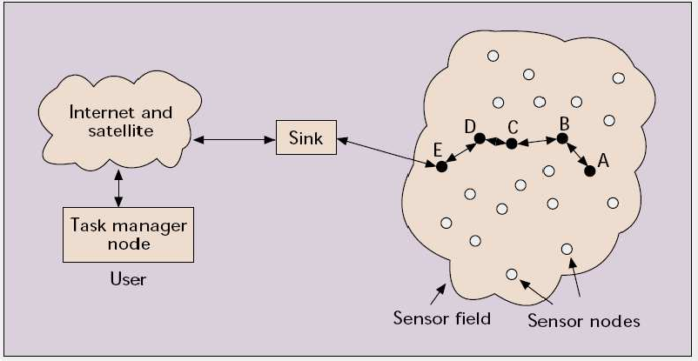

**Fig. General Architecture of WSN**

The deployment of CMOS chips for WSNodes results into not only miniaturization but also reduction of power consumption. The WSN can be categorized into two groups

### Category-1: (C1WSN):

Emphasizes mesh-based systems with multi-hop radio connectivity among the WSNodes and realizes dynamic routing of WSNodes within the establishment of WSN

### Category-2: (C2WSN):

The WSN of this category ensures point-to-point connectivity between WSNodes with single-hop technique. These networks reveal static routing of the WSNodes.

Figure [1.2] and figure [1.3] depict the schematic of C1WSN and C2WSN respectively.

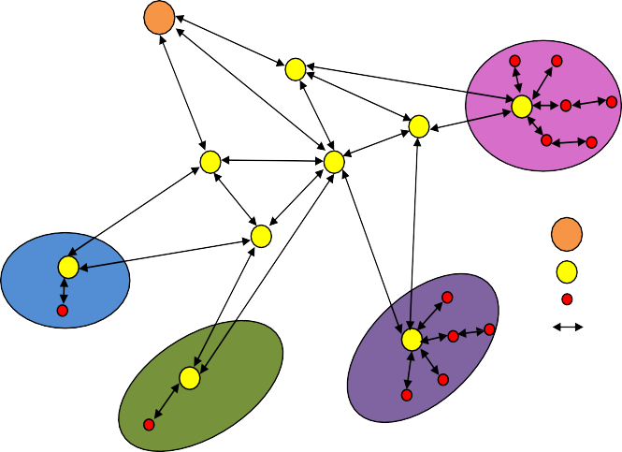

Data Sink Point

Wireless Router

End Device Radio Link

**Figure 1.3:** Schematic of WSN of Category-1.

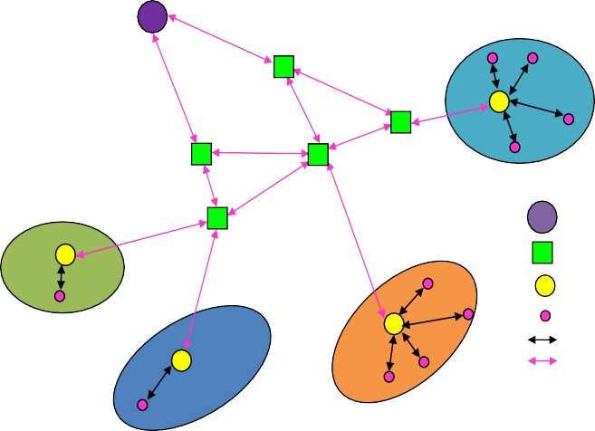

Data Sink Point

Terrestrial Router

Static Route Wireless Router End Device

Radio Link Terrestrial Link

**Figure 1.4:** Schematic of WSN of category-2.

4.2 IOT(Internet of Things)

Internet of thing (IoT) [1, 2,] is a fast-growing collection of internet-connected sensors embedded in a wide-ranging variety of physical objects i.e. things. Whereas things can literally be any physical object (animate or inanimate) on the planet, to which you could connect or embed a sensor and capable to communicate with each other and physical environment too [121]. Sensors can take a large number of possible measurements. Internet connectivity to the things can be either wired or wireless. These things are generating huge amounts of new, structured, unstructured, real-time data. Advances of IoT is the result of advances in the various field such as electronics devices, communication technology and web. Current IoT is the result of amalgamation of three main visions i.e. Things oriented, Internet oriented, semantic oriented which is shown in In Fig. 3.1.

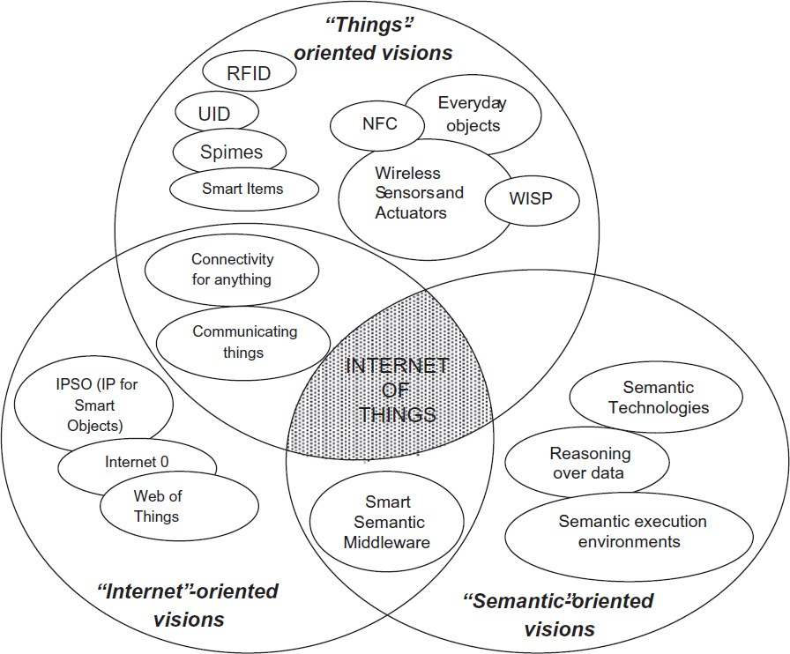

Fig. 3.1. ‗‗Internet of Things‖ is the amalgamation of three visions [4]

Things oriented vision comprises various things such as, RFID, UID, NFC, smart items, everyday objects, wireless sensors and actuators.

# **Simulation of IoT Network Architecture**

Various IoT platforms are studied. We selected IoTZetta because it overcomes the issues in existing IoT platforms.

Table 3.1 IoT Issues with its description and solution provided by IoT Zetta

|  |  |  |  |
| --- | --- | --- | --- |
| Sr.  No. | Issues in IoT | Description | Solution Provided by Zetta |
| 1 | Too many  protocols and interfaces exist | Too many interfaces and protocols exist amongst them which one is to use, whether a provision is made for standard future proofing and security provision against these new protocols or not made is unknown. | Use of HTTP protocol to communicate with all devices. Every device gets an API generated from Node.js |
| 2 | Large number of devices in systems | Large no of devices are involved in IoT system, there is necessity to have a standard mechanism to coordinate these large number of devices by providing various types of communication such as D2D: Device to Device, D2G: Device to Gateways, D2C: Device to cloud, S2S: server to server communication in large IoT systems and must improve on emergent behaviors of these devices in large systems. | With the use of REST API, web sockets and reactive programming it coordinates devices across the globe with ease. |
| 3 | IoT Devices generate huge amount of data | In upcoming years IoT will become the biggest source of data on the planet and we | Broadcasting data over web sockets. Analyzing the data made easy. |

|  |  |  |  |
| --- | --- | --- | --- |
|  |  | must be prepared for handling such huge data. We must address issues related to IoT Data such as, which data need to be stored, what techniques we must adopt for storing, how to extract meaningful information and learn from this IoT Data. |  |
| 4 | Quality of Tooling. | While building IoT tool few things need to be addressed such as, what things need to be considered while building IoT products, soon there will be a shortage of developers with necessary experience of technology who can build IoT products because in today‘s scenarios limited number of developers available, has experiences on multiple technologies, multiple APPs, multiple devices but once the IoT technology gets matured there will be only one big ecosystem, one big app, multiple devices and developer must be expertized in only technology in which IoT ecosystem is developed. | Designed with the developer in mind.  Multiple tools are provided to help developer to build the tool quickly. |

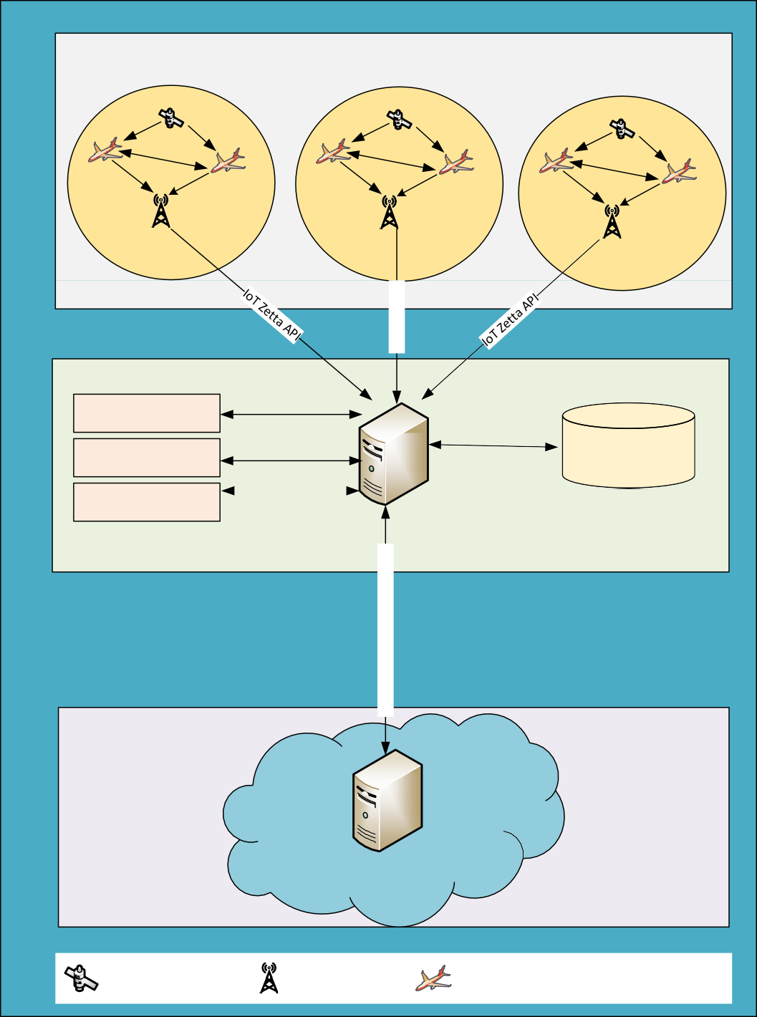

IoT Zetta Clients

IoT Zetta Client

**ADS­B**

**Receiver**

**ADS­B**

**Receiver**

**ADS­B**

**Receiver**

**Driver**

**Server Extensions**

**Zetta Server**

**Scouts** **Clients Registry**

IoT Zetta Cloud Server

GPS Satellite ADS­B receiver ADS­B Transponder equipped aircraft

Fig. The architecture of IOT

Fig. The architecture of IOT

CHAPTER 5: ALGORITHMS

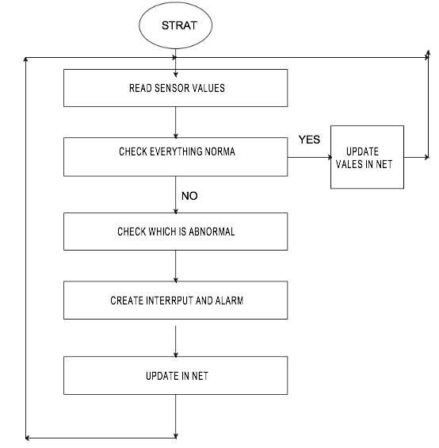

Sensors continuously monitors the gases in the surrounding and posts in to the server for storing and usage of data futurly. While continuously monitoring if any gas level exceed the range to that of normal range in air the alert will be enhanced and a SMS notification will be posted to safety control board of organization and even to the workers mobile station only if required.

CHAPTER 6: DATA FLOW DIAGRAM

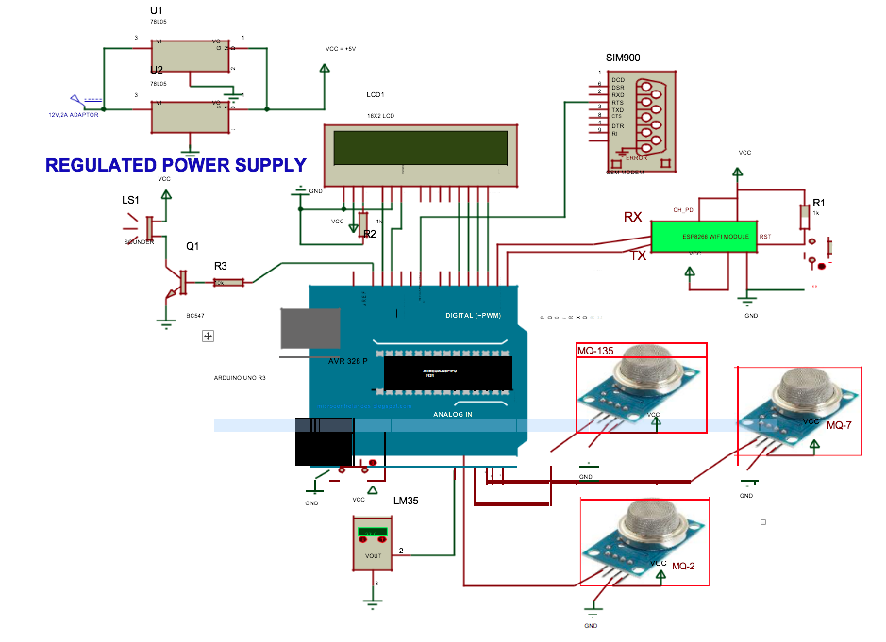

Proteus 8.0 expert is a best re-enactment for different plan with Ardunio Uno r3. It's for the most part prominent in light of accessibility of all microcontrollers in it. So it's helpful instrument to test programs and inserted plan for hardware specialist. You can reenact your programming of Ardunio Uno r3 in Proteus 8.0 Simulation Software. In the wake of reenacting your circuit in Proteus 8.0 Software. Proteus is the application for making virtual System Modeling and circuit Simulations. Proteus additionally can reproduce the cooperation between programming running on an Ardunio Uno r3 and any simple or computerized gadgets associated with it. Proteus can recreates output and input ports, interferes with, clocks USART and every other fringe show on each help processor

**CHAPTER 7: MODULES**

a) Arduino sensors :

1. MQ-2

Introduction:

The MQ-2 is a flammable gas and smoke sensor detects the concentrations of combustible gas in the air and outputs its reading as an analog voltage.The sensor can measure concentrations of flammable gas of 300 to 10,000 ppm.The MQ-2 gas sensor is sensitive to LPG, i-butane, propane, methane, alcohol, Hydrogen and smoke.They are used in gas leakage detecting equipments in family and industry and in portable gas detector.For details,visit the [datasheet](https://wiki.eprolabs.com/index.php?title=File:SEN-0042.pdf).

Specifications:

* Supply Voltage:5V
* Sensitive to H2, LPG, CH4, CO, Alcohol, Smoke or Propane
* Analog and Digital Output
* Digital Out is High or Low based on a adjustable preset threshold

How to connect Smoke sensor with Arduino?

Hardware and Software Required

* MQ2 Smoke sensor Module
* Arduino Uno
* Arduino IDE(1.0.6 Version)

Hardware Connections:

The connections are made as follows:

* Vcc to 5V
* GND to GND
* A0 to Analog0

Program for Smoke sensor MQ2:

The program will generate a sensor value as output in the serial monitor.

const int sensorPin = A0; //GAS sensor output pin to Arduino analog A0 pin

void setup()

{ Serial.begin(9600); //Initialize serial port - 9600 bps

}

void loop()

{ Serial.println(analogRead(sensorPin));

delay(1000); // Print value every 1 sec.

}

References:

* MQ Gas sensors
* Smoke & Gas Sensor for Electronics Projects- MQ2
* MQ-2 Smoke Sensor Circuit Built with an Arduino

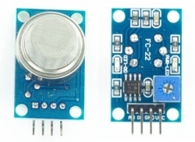

1. MQ135:

Introduction:

Air quality sensor for detecting a wide range of gases, including NH3, NOx, alcohol, benzene, smoke and CO2. Ideal for use in office or factory. MQ135 gas sensor has high sensitivity to Ammonia, Sulfide and Benze steam, also sensitive to smoke and other harmful gases. It is with low cost and particularly suitable for Air quality monitoring application.

It is a hazardous gas detection apparatus for the family, the environment, suitable for ammonia, aromatic compounds, sulphur, benzene vapour, smoke and other gases harmful gas detection, gas-sensitive element test.

Air quality sensor is for detecting a wide range of gases, including NH3, NOx, alcohol, benzene, smoke and CO2. Ideal for use in office or factory with simple drive and monitoring circuit.

The MQ135 Air Quality Sensor consists of a small sensing material whose conductivity is lower in clean air and higher in polluted air, thus making the sensor very useful while detecting dangerous gases. The sensor ionizes the gases which come in its contact, making changes in the resistance of the sensing material.

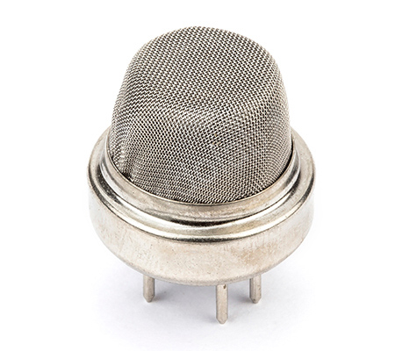

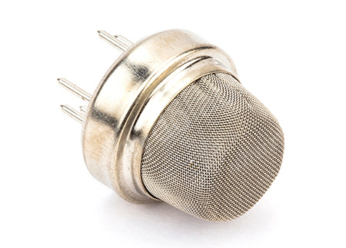

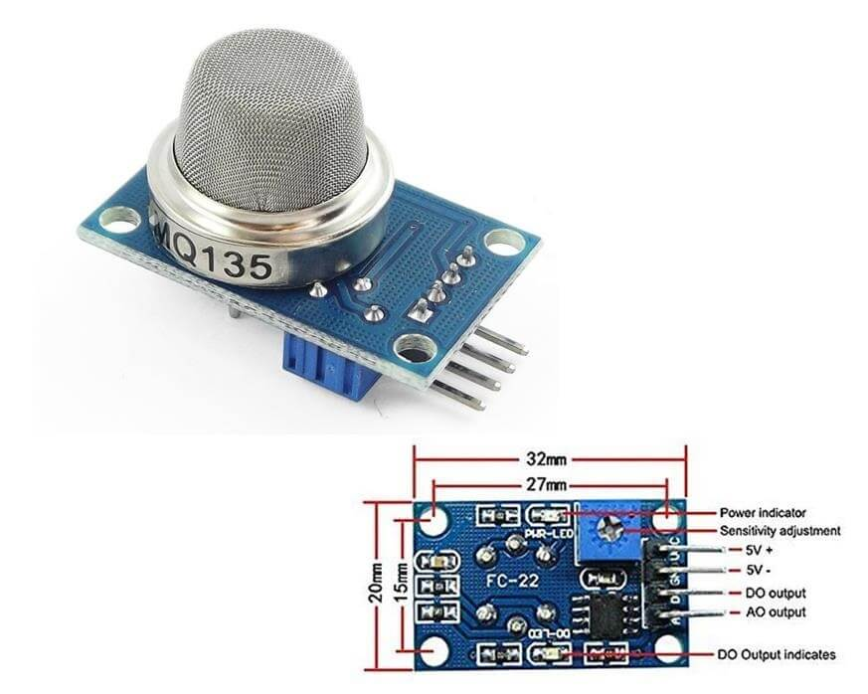

Features:

* High Sensitivity
* High sensitivity to Ammonia, Sulfide and Benze
* Stable and Long Life
* Detection Range: 10 - 300 ppm NH3, 10 - 1000 ppm Benzene, 10 - 300 Alcohol
* Heater Voltage: 5.0V
* Dimensions: 18mm Diameter, 17mm High excluding pins, Pins - 6mm High
* Long life and low cost
* Wide detecting scope
* Fast response and High sensitivity
* Stable and long life
* Operating Voltage is +5VDC
* Detect/Measure NH3, NOx, alcohol, Benzene, smoke, CO2, etc.
* Analog output voltage: 0V to 5V
* Digital output voltage: 0V or 5V (TTL Logic)
* Preheat duration 20 seconds
* Can be used as a digital or analog sensor
* The Sensitivity of digital output can be adjusted using on board potentiometer
* The TTL output valid signal is low. (When the output is low, the signal light is on, it can be directly connected to the MCU or relay module)
* The voltage of the analog output, the higher the concentration, the higher the voltage.
* Arduino compatible
* Comes with 4 mounting screw holes (M3 or 3mm size)
* Product dimensions: 32 (L) * 20 (W) * 22 (H)

Applications:

* Domestic air pollution detector
* Industrial air pollution detector
* Portable air pollution detector

#### MQ135 Spec:

Detection of gas: Ammonia /Sulfide/ Benzene vapor

Detection of Concentration:10-1000ppm

Input voltage: DC 5V

Power consumption (current): 150mA

AO output: 0.1-0.3V (relatively non-polluting), the highest concentration voltage is about 4V

b) PCB board:

Introduction:

A printed circuit board (PCB) mechanically supports and electrically connects electrical or electronic components using conductive tracks, pads and other features etched from one or more sheet layers of copper laminated onto and/or between sheet layers of a non-conductive substrate. Components are generally soldered onto the PCB to both electrically connect and mechanically fasten them to it.

Printed circuit boards are used in all but the simplest electronic products. They are also used in some electrical products, such as passive switch boxes.

Alternatives to PCBs include wire wrap and point-to-point construction, both once popular but now rarely used. PCBs require additional design effort to lay out the circuit, but manufacturing and assembly can be automated. Electronic computer-aided design software is available to do much of the work of layout. Mass-producing circuits with PCBs is cheaper and faster than with other wiring methods, as components are mounted and wired in one operation. Large numbers of PCBs can be fabricated at the same time, and the layout only has to be done once. PCBs can also be made manually in small quantities, with reduced benefits.

PCBs can be single-sided (one copper layer), double-sided (two copper layers on both sides of one substrate layer), or multi-layer (outer and inner layers of copper, alternating with layers of substrate). Multi-layer PCBs allow for much higher component density, because circuit traces on the inner layers would otherwise take up surface space between components. The rise in popularity of multilayer PCBs with more than two, and especially with more than four, copper planes was concurrent with the adoption of surface mount technology. However, multilayer PCBs make repair, analysis, and field modification of circuits much more difficult and usually impractical.

The world market for bare PCBs exceeded $60.2 billion in 2014.[1] In 2018, the Global Single Sided Printed Circuit Board Market Analysis Report estimated that the PCB market would reach $79 billion by 2024.

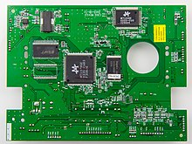

Overview:

A basic PCB consists of a flat sheet of insulating material and a layer of copper foil, laminated to the substrate. Chemical etching divides the copper into separate conducting lines called tracks or circuit traces, pads for connections, vias to pass connections between layers of copper, and features such as solid conductive areas for electromagnetic shielding or other purposes. The tracks function as wires fixed in place, and are insulated from each other by air and the board substrate material. The surface of a PCB may have a coating that protects the copper from corrosion and reduces the chances of solder shorts between traces or undesired electrical contact with stray bare wires. For its function in helping to prevent solder shorts, the coating is called solder resist or solder mask.

A printed circuit board can have multiple copper layers. A two-layer board has copper on both sides; multi layer boards sandwich additional copper layers between layers of insulating material. Conductors on different layers are connected with vias, which are copper-plated holes that function as electrical tunnels through the insulating substrate. Through-hole component leads sometimes also effectively function as vias. After two-layer PCBs, the next step up is usually four-layer. Often two layers are dedicated as power supply and ground planes, and the other two are used for signal wiring between components.

"Through hole" components are mounted by their wire leads passing through the board and soldered to traces on the other side. "Surface mount" components are attached by their leads to copper traces on the same side of the board. A board may use both methods for mounting components. PCBs with only through-hole mounted components are now uncommon. Surface mounting is used for transistors, diodes, IC chips, resistors and capacitors.

Through-hole mounting may be used for some large components such as electrolytic capacitors and connectors.

The pattern to be etched into each copper layer of a PCB is called the "artwork". The etching is usually done using photoresist which is coated onto the PCB, then exposed to light projected in the pattern of the artwork. The resist material protects the copper from dissolution into the etching solution. The etched board is then cleaned. A PCB design can be mass-reproduced in a way similar to the way photographs can be mass-duplicated from film negatives using a photographic printer.

In multi-layer boards, the layers of material are laminated together in an alternating sandwich: copper, substrate, copper, substrate, copper, etc.; each plane of copper is etched, and any internal vias (that will not extend to both outer surfaces of the finished multilayer board) are plated-through, before the layers are laminated together. Only the outer layers need be coated; the inner copper layers are protected by the adjacent substrate layers.

FR-4 glass epoxy is the most common insulating substrate. Another substrate material is cotton paper impregnated with phenolic resin, often tan or brown.

When a PCB has no components installed, it is less ambiguously called a printed wiring board (PWB) or etched wiring board. However, the term "printed wiring board" has fallen into disuse. A PCB populated with electronic components is called a printed circuit assembly (PCA), printed circuit board assembly or PCB assembly (PCBA). In informal usage, the term "printed circuit board" most commonly means "printed circuit assembly" (with components).

The IPC preferred term for assembled boards is circuit card assembly (CCA),[4] and for assembled backplanes it is backplane assemblies. "Card" is another widely used informal term for a "printed circuit assembly". For example, expansion card.

A PCB may be "silkscreen" printed with a legend identifying the components, test points, or identifying text. Originally, an actual silkscreen printing process was used for this purpose, but today other, finer quality printing methods are usually used instead. Normally the screen printing is not significant to the function of the PCBA.

A minimal PCB for a single component, used for prototyping, is called a breakout board. The purpose of a breakout board is to "break out" the leads of a component on separate terminals so that manual connections to them can be made easily. Breakout boards are especially used for surface-mount components or any components with fine lead pitch.

Advanced PCBs may contain components embedded in the substrate.

Characteristics:

Through-hole technology:

The first PCBs used through-hole technology, mounting electronic components by leads inserted through holes on one side of the board and soldered onto copper traces on the other side. Boards may be single-sided, with an unplated component side, or more compact double-sided boards, with components soldered on both sides. Horizontal installation of through-hole parts with two axial leads (such as resistors, capacitors, and diodes) is done by bending the leads 90 degrees in the same direction, inserting the part in the board (often bending leads located on the back of the board in opposite directions to improve the part's mechanical strength), soldering the leads, and trimming off the ends. Leads may be soldered either manually or by a wave soldering machine.

Through-hole manufacture adds to board cost by requiring many holes to be drilled accurately, and it limits the available routing area for signal traces on layers immediately below the top layer on multi-layer boards, since the holes must pass through all layers to the opposite side. Once surface-mounting came into use, small-sized SMD components were used where possible, with through-hole mounting only of components unsuitably large for surface-mounting due to power requirements or mechanical limitations, or subject to mechanical stress which might damage the PCB (e.g. by lifting the copper off the board surface).[citation needed]

Surface-mount technology:

Surface mount components, including resistors, transistors and an integrated circuit

Surface-mount technology emerged in the 1960s, gained momentum in the early 1980s and became widely used by the mid-1990s. Components were mechanically redesigned to have small metal tabs or end caps that could be soldered directly onto the PCB surface, instead of wire leads to pass through holes. Components became much smaller and component placement on both sides of the board became more common than with through-hole mounting, allowing much smaller PCB assemblies with much higher circuit densities. Surface mounting lends itself well to a high degree of automation, reducing labor costs and greatly increasing production rates compared with through-hole circuit boards. Components can be supplied mounted on carrier tapes. Surface mount components can be about one-quarter to one-tenth of the size and weight of through-hole components, and passive components much cheaper. However, prices of semiconductor surface mount devices (SMDs) are determined more by the chip itself than the package, with little price advantage over larger packages, and some wire-ended components, such as 1N4148 small-signal switch diodes, are actually significantly cheaper than SMD equivalents.

A PCB in a computer mouse: the component side (left) and the printed side (right)

Circuit properties of the PCB:

Each trace consists of a flat, narrow part of the copper foil that remains after etching. Its resistance, determined by its width, thickness, and length, must be sufficiently low for the current the conductor will carry. Power and ground traces may need to be wider than signal traces. In a multi-layer board one entire layer may be mostly solid copper to act as a ground plane for shielding and power return. For microwave circuits, transmission lines can be laid out in a planar form such as stripline or microstrip with carefully controlled dimensions to assure a consistent impedance. In radio-frequency and fast switching circuits the inductance and capacitance of the printed circuit board conductors become significant circuit elements, usually undesired; conversely, they can be used as a deliberate part of the circuit design, as in distributed-element filters, antennae, and fuses, obviating the need for additional discrete components. High density interconnects (HDI) PCBs have tracks and/or vias with a width or diameter of under 152 micrometers.

Materials:

The European Union bans the use of lead (among other heavy metals) in consumer items, a piece of legislature called the RoHS, for Restriction of Hazardous Substances, directive. PCBs to be sold in the EU must be RoHS-compliant, meaning that all manufacturing processes must not involve the use of lead, all solder used must be lead-free, and all components mounted on the board must be free of lead, mercury, cadmium, and other heavy metals.

Laminates:

Laminates are manufactured by curing under pressure and temperature layers of cloth or paper with thermoset resin to form an integral final piece of uniform thickness. The size can be up to 4 by 8 feet (1.2 by 2.4 m) in width and length. Varying cloth weaves (threads per inch or cm), cloth thickness, and resin percentage are used to achieve the desired final thickness and dielectric characteristics. Available standard laminate thickness are listed in ANSI/IPC-D-275.

The cloth or fiber material used, resin material, and the cloth to resin ratio determine the laminate's type designation (FR-4, CEM-1, G-10, etc.) and therefore the characteristics of the laminate produced. Important characteristics are the level to which the laminate is fire retardant, the dielectric constant (er), the loss factor (tδ), the tensile strength, the shear strength, the glass transition temperature (Tg), and the Z-axis expansion coefficient (how much the thickness changes with temperature).

There are quite a few different dielectrics that can be chosen to provide different insulating values depending on the requirements of the circuit. Some of these dielectrics are polytetrafluoroethylene (Teflon), FR-4, FR-1, CEM-1 or CEM-3. Well known pre-preg materials used in the PCB industry are FR-2 (phenolic cotton paper), FR-3 (cotton paper and epoxy), FR-4 (woven glass and epoxy), FR-5 (woven glass and epoxy), FR-6 (matte glass and polyester), G-10 (woven glass and epoxy), CEM-1 (cotton paper and epoxy), CEM-2 (cotton paper and epoxy), CEM-3 (non-woven glass and epoxy), CEM-4 (woven glass and epoxy), CEM-5 (woven glass and polyester). Thermal expansion is an important consideration especially with ball grid array (BGA) and naked die technologies, and glass fiber offers the best dimensional stability.

FR-4 is by far the most common material used today. The board stock with unetched copper on it is called "copper-clad laminate".

With decreasing size of board features and increasing frequencies, small nonhomogeneities like uneven distribution of fiberglass or other filler, thickness variations, and bubbles in the resin matrix, and the associated local variations in the dielectric constant, are gaining importance.

Key substrate parameters:

The circuitboard substrates are usually dielectric composite materials. The composites contain a matrix (usually an epoxy resin) and a reinforcement (usually a woven, sometimes nonwoven, glass fibers, sometimes even paper), and in some cases a filler is added to the resin (e.g. ceramics; titanate ceramics can be used to increase the dielectric constant).

The reinforcement type defines two major classes of materials: woven and non-woven. Woven reinforcements are cheaper, but the high dielectric constant of glass may not be favorable for many higher-frequency applications. The spatially nonhomogeneous structure also introduces local variations in electrical parameters, due to different resin/glass ratio at different areas of the weave pattern. Nonwoven reinforcements, or materials with low or no reinforcement, are more expensive but more suitable for some RF/analog applications.

The substrates are characterized by several key parameters, chiefly thermomechanical (glass transition temperature, tensile strength, shear strength, thermal expansion), electrical (dielectric constant, loss tangent, dielectric breakdown voltage, leakage current, tracking resistance...), and others (e.g. moisture absorption).

At the glass transition temperature the resin in the composite softens and significantly increases thermal expansion; exceeding Tg then exerts mechanical overload on the board components - e.g. the joints and the vias. Below Tg the thermal expansion of the resin roughly matches copper and glass, above it gets significantly higher. As the reinforcement and copper confine the board along the plane, virtually all volume expansion projects to the thickness and stresses the plated-through holes. Repeated soldering or other exposition to higher temperatures can cause failure of the plating, especially with thicker boards; thick boards therefore require a matrix with a high Tg.

The materials used determine the substrate's dielectric constant. This constant is also dependent on frequency, usually decreasing with frequency. As this constant determines the signal propagation speed, frequency dependence introduces phase distortion in wideband applications; as flat a dielectric constant vs frequency characteristics as is achievable is important here. The impedance of transmission lines decreases with frequency, therefore faster edges of signals reflect more than slower ones.

Dielectric breakdown voltage determines the maximum voltage gradient the material can be subjected to before suffering a breakdown (conduction, or arcing, through the dielectric).

Tracking resistance determines how the material resists high voltage electrical discharges creeping over the board surface.

Loss tangent determines how much of the electromagnetic energy from the signals in the conductors is absorbed in the board material. This factor is important for high frequencies. Low-loss materials are more expensive. Choosing unnecessarily low-loss material is a common engineering error in high-frequency digital design; it increases the cost of the boards without a corresponding benefit. Signal degradation by loss tangent and dielectric constant can be easily assessed by an eye pattern.

Moisture absorption occurs when the material is exposed to high humidity or water. Both the resin and the reinforcement may absorb water; water also may be soaked by capillary forces through voids in the materials and along the reinforcement. Epoxies of the FR-4 materials are not too susceptible, with absorption of only 0.15%. Teflon has very low absorption of 0.01%. Polyimides and cyanate esters, on the other side, suffer from high water absorption. Absorbed water can lead to significant degradation of key parameters; it impairs tracking resistance, breakdown voltage, and dielectric parameters. Relative dielectric constant of water is about 73, compared to about 4 for common circuit board materials. Absorbed moisture can also vaporize on heating, as during soldering, and cause cracking and delamination,[10] the same effect responsible for "popcorning" damage on wet packaging of electronic parts. Careful baking of the substrates may be required to dry them prior to soldering.

Plating and coating:

Proper plating or surface finish selection can be critical to process yield, the amount of rework, field failure rate, and reliability.

PCBs are plated with solder, tin, or gold over nickel and a resist for etching away the unneeded underlying copper.

After PCBs are etched and then rinsed with water, the solder mask is applied, and then any exposed copper is coated with solder, nickel/gold, or some other anti-corrosion coating.

Matte solder is usually fused to provide a better bonding surface for bare copper. Treatments, such as benzimidazolethiol, prevent surface oxidation of bare copper. The places to which components will be mounted are typically plated, because untreated bare copper oxidizes quickly, and therefore is not readily solderable. Traditionally, any exposed copper was coated with solder by hot air solder levelling (HASL). The HASL finish prevents oxidation from the underlying copper, thereby guaranteeing a solderable surface. This solder was a tin-lead alloy, however new solder compounds are now used to achieve compliance with the RoHS directive in the EU, which restricts the use of lead. One of these lead-free compounds is SN100CL, made up of 99.3% tin, 0.7% copper, 0.05% nickel, and a nominal of 60 ppm germanium.

It is important to use solder compatible with both the PCB and the parts used. An example is ball grid array (BGA) using tin-lead solder balls for connections losing their balls on bare copper traces or using lead-free solder paste.

Other platings used are OSP (organic surface protectant), immersion silver (IAg), immersion tin, electroless nickel with immersion gold coating (ENIG), electroless nickel electroless palladium immersion gold (ENEPIG) and direct gold plating (over nickel). Edge connectors, placed along one edge of some boards, are often nickel-plated then gold-plated. Another coating consideration is rapid diffusion of coating metal into tin solder. Tin forms intermetallics such as Cu6Sn5 and Ag3Cu that dissolve into the Tin liquidus or solidus (at 50 °C), stripping surface coating or leaving voids.

Electrochemical migration (ECM) is the growth of conductive metal filaments on or in a printed circuit board (PCB) under the influence of a DC voltage bias.[39][40] Silver, zinc, and aluminum are known to grow whiskers under the influence of an electric field. Silver also grows conducting surface paths in the presence of halide and other ions, making it a poor choice for electronics use. Tin will grow "whiskers" due to tension in the plated surface. Tin-lead or solder plating also grows whiskers, only reduced by reducing the percentage of tin. Reflow to melt solder or tin plate to relieve surface stress lowers whisker incidence. Another coating issue is tin pest, the transformation of tin to a powdery allotrope at low temperature.

c) Arduino nano:

Introduction:

The Arduino Nano is a small, complete, and breadboard-friendly board based on the ATmega328 (Arduino Nano 3.x) or ATmega168 (Arduino Nano 2.x). It has more or less the same functionality of the Arduino Duemilanove, but in a different package.

Arduino Nano V3.0

It lacks only a DC power jack, and works with a Mini-B USB cable instead of a standard one.The Arduino Nano can be powered via the Mini-B USB connection, 6-20V unregulated external power supply (pin 30), or 5V regulated external power supply (pin 27). The power source is automatically selected to the highest voltage source.

Arduino is an open-source hardware and software company, project and user community that designs and manufactures single-board microcontrollers and microcontroller kits for building digital devices. Its products are licensed under the GNU Lesser General Public License (LGPL) or the GNU General Public License (GPL),[1] permitting the manufacture of Arduino boards and software distribution by anyone. Arduino boards are available commercially in preassembled form or as do-it-yourself (DIY) kits.

Arduino board designs use a variety of microprocessors and controllers. The boards are equipped with sets of digital and analog input/output (I/O) pins that may be interfaced to various expansion boards ('shields') or breadboards (For prototyping) and other circuits. The boards feature serial communications interfaces, including Universal Serial Bus (USB) on some models, which are also used for loading programs from personal computers. The microcontrollers can be programmed using C and C++ programming languages. In addition to using traditional compiler toolchains, the Arduino project provides an integrated development environment (IDE) based on the Processing language project.

The Arduino project started in 2005 as a program for students at the Interaction Design Institute Ivrea in Ivrea, Italy,[2] aiming to provide a low-cost and easy way for novices and professionals to create devices that interact with their environment using sensors and actuators. Common examples of such devices intended for beginner hobbyists include simple robots, thermostats and motion detectors.

The name Arduino comes from a bar in Ivrea, Italy, where some of the founders of the project used to meet. The bar was named after Arduin of Ivrea, who was the margrave of the March of Ivrea and King of Italy from 1002 to 1014.

## Overview:

The Arduino Nano is a small, complete, and breadboard-friendly board based on the ATmega328 (Arduino Nano 3.0) or ATmega168 (Arduino Nano 2.x). It has more or less the same functionality of the Arduino Duemilanove, but in a different package. It lacks only a DC power jack, and works with a Mini-B USB cable instead of a standard one. The Nano was designed and is being produced by Gravitech.

[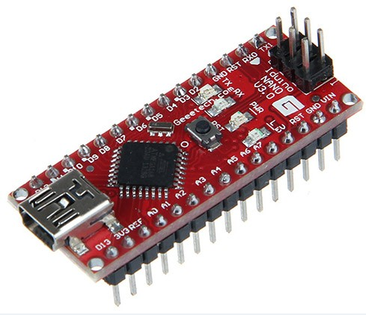](https://www.geeetech.com/wiki/index.php/File:NANO.jpg)

Arduino Nano 2.3 (ATmega168): [manual](http://arduino.cc/en/uploads/Main/ArduinoNanoManual23.pdf) (pdf), [Eagle files](http://gravitech.us/Arduino/Arduino_Nano_V2_3_Eagle.zip). Note: since the free version of Eagle does not handle more than 2 layers, and this version of the Nano is 4 layers, it is published here unrouted, so users can open and use it in the free version of Eagle.

Specifications:

* Microcontroller Atmel ATmega168 or ATmega328
* Operating Voltage: (logic level) 5 V
* Input Voltage: (recommended) 7-12 V
* Input Voltage: (limits) 6-20 V
* Digital I/O Pins: 14 (of which 6 provide PWM output)
* Analog Input Pins: 8
* DC Current per I/O Pin: 40 mA
* Flash Memory: 16 KB (ATmega168) or 32 KB (ATmega328) of which 2 KB used by bootloader
* SRAM: 1 KB (ATmega168) or 2 KB (ATmega328)
* EEPROM: 512 bytes (ATmega168) or 1 KB (ATmega328)
* Clock Speed: 16 MHz
* Dimensions: 0.73" x 1.70"

Power:

The Arduino Nano can be powered via the Mini-B USB connection, 6-20V unregulated external power supply (pin 30), or 5V regulated external power supply (pin 27). The power source is automatically selected to the highest voltage source.

The FTDI FT232RL chip on the Nano is only powered if the board is being powered over USB. As a result, when running on external (non-USB) power, the 3.3V output (which is supplied by the FTDI chip) is not available and the RX and TX LEDs will flicker if digital pins 0 or 1 are high.

Memory:

The ATmega168 has 16 KB of flash memory for storing code (of which 2 KB is used for the bootloader); the ATmega328 has 32 KB, (also with 2 KB used for the bootloader). The ATmega168 has 1 KB of SRAM and 512 bytes of EEPROM (which can be read and written with the EEPROM library); the ATmega328 has 2 KB of SRAM and 1 KB of EEPROM.

Input and Output:

Each of the 14 digital pins on the Nano can be used as an input or output, using pinMode(), digitalWrite(), and digitalRead() functions. They operate at 5 volts. Each pin can provide or receive a maximum of 40 mA and has an internal pull-up resistor (disconnected by default) of 20-50 kOhms. In addition, some pins have specialized functions: Serial: 0 (RX) and 1 (TX). Used to receive (RX) and transmit (TX) TTL serial data. These pins are connected to the corresponding pins of the FTDI USB-to-TTL Serial chip. External Interrupts: 2 and 3. These pins can be configured to trigger an interrupt on a low value, a rising or falling edge, or a change in value. See the attachInterrupt() function for details.

PWM: 3, 5, 6, 9, 10, and 11. Provide 8-bit PWM output with the analogWrite() function.

SPI: 10 (SS), 11 (MOSI), 12 (MISO), 13 (SCK). These pins support SPI communication, which, although provided by the underlying hardware, is not currently included in the Arduino language.

LED: 13. There is a built-in LED connected to digital pin 13. When the pin is HIGH value, the LED is on, when the pin is LOW, it's off.

The Nano has 8 analog inputs, each of which provide 10 bits of resolution (i.e. 1024 different values). By default they measure from ground to 5 volts, though is it possible to change the upper end of their range using the analogReference() function. Additionally, some pins have specialized functionality:

* I2C: 4 (SDA) and 5 (SCL). Support I2C (TWI) communication using the Wire library (documentation on the Wiring website).

There are a couple of other pins on the board:

* AREF. Reference voltage for the analog inputs. Used with analogReference().
* Reset. Bring this line LOW to reset the microcontroller. Typically used to add a reset button to shields which block the one on the board.

Communication:

The Arduino Nano has a number of facilities for communicating with a computer, another Arduino, or other microcontrollers. The ATmega168 and ATmega328 provide UART TTL (5V) serial communication, which is available on digital pins 0 (RX) and 1 (TX). An FTDI FT232RL on the board channels this serial communication over USB and the FTDI drivers (included with the Arduino software) provide a virtual com port to software on the computer. The Arduino software includes a serial monitor which allows simple textual data to be sent to and from the Arduino board. The RX and TX LEDs on the board will flash when data is being transmitted via the FTDI chip and USB connection to the computer (but not for serial communication on pins 0 and 1).

A SoftwareSerial library allows for serial communication on any of the Nano's digital pins.

The ATmega168 and ATmega328 also support I2C (TWI) and SPI communication. The Arduino software includes a Wire library to simplify use of the I2C bus; see the documentation for details. To use the SPI communication, please see the ATmega168 or ATmega328 datasheet.

Programming:

The Arduino Nano can be programmed with the Arduino software (download). Select "Arduino Diecimila, Duemilanove, or Nano w/ ATmega168" or "Arduino Duemilanove or Nano w/ ATmega328" from the Tools > Board menu (according to the microcontroller on your board). For details, see the reference and tutorials.

The ATmega168 or ATmega328 on the Arduino Nano comes preburned with a bootloader that allows you to upload new code to it without the use of an external hardware programmer. It communicates using the original STK500 protocol (reference, C header files).

You can also bypass the bootloader and program the microcontroller through the ICSP (In-Circuit Serial Programming) header; see these instructions for details.

Automatic (Software) Reset:

Rather then requiring a physical press of the reset button before an upload, the Arduino Nano is designed in a way that allows it to be reset by software running on a connected computer. One of the hardware flow control lines (DTR) of the FT232RL is connected to the reset line of the ATmega168 or ATmega328 via a 100 nanofarad capacitor. When this line is asserted (taken low), the reset line drops long enough to reset the chip. The Arduino software uses this capability to allow you to upload code by simply pressing the upload button in the Arduino environment. This means that the bootloader can have a shorter timeout, as the lowering of DTR can be well-coordinated with the start of the upload.

This setup has other implications. When the Nano is connected to either a computer running Mac OS X or Linux, it resets each time a connection is made to it from software (via USB). For the following half-second or so, the bootloader is running on the Nano. While it is programmed to ignore malformed data (i.e. anything besides an upload of new code), it will intercept the first few bytes of data sent to the board after a connection is opened. If a sketch running on the board receives one-time configuration or other data when it first starts, make sure that the software with which it communicates waits a second after opening the connection and before sending this data.

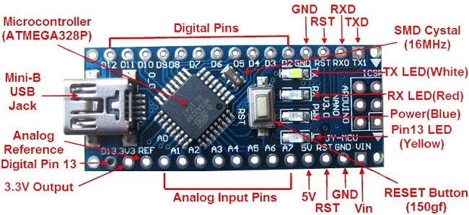

d)Wi-Fi:

Introduction:

Wi-Fi is a family of wireless networking technologies, based on the IEEE 802.11 family of standards, which are commonly used for local area networking of devices and Internet access. Wi‑Fi is a trademark of the non-profit Wi-Fi Alliance, which restricts the use of the term Wi-Fi Certified to products that successfully complete interoperability certification testing. As of 2010, the Wi-Fi Alliance consisted of more than 375 companies from around the world. As of 2009, Wi-Fi-integrated circuit chips shipped approximately 580 million units yearly.Devices that can use Wi-Fi technologies include desktops and laptops, smartphones and tablets, smart TVs, printers, digital audio players, digital cameras, cars and drones.

Wi-Fi uses multiple parts of the IEEE 802 protocol family, and is designed to interwork seamlessly with its wired sibling Ethernet. Compatible devices can network through wireless access points to each other as well as to wired devices and the Internet. The different versions of Wi-Fi are specified by various IEEE 802.11 protocol standards, with the different radio technologies determining radio bands, and the maximum ranges, and speeds that may be achieved. Wi-Fi most commonly uses the 2.4 gigahertz (120 mm) UHF and 5 gigahertz (60 mm) SHF ISM radio bands; these bands are subdivided into multiple channels. Channels can be shared between networks but only one transmitter can locally transmit on a channel at any moment in time.

Wi-Fi's wavebands have relatively high absorption and work best for line-of-sight use. Many common obstructions such as walls, pillars, home appliances etc. may greatly reduce range, but this also helps minimize interference between different networks in crowded environments. An access point (or hotspot) often has a range of about 20 metres (66 feet) indoors while some modern access points claim up to a 150-metre (490-foot) range outdoors. Hotspot coverage can be as small as a single room with walls that block radio waves, or as large as many square kilometers using many overlapping access points with roaming permitted between them. Over time the speed and spectral efficiency of Wi-Fi has increased. As of 2019, at close range, some versions of Wi-Fi, running on suitable hardware, can achieve speeds of over 1 Gbit/s (gigabit per second).

Wi-Fi is potentially more vulnerable to attack than wired networks because anyone within range of a network with a wireless network interface controller can attempt access. To connect to a Wi-Fi network, a user typically needs the network name (the SSID) and a password. The password is used to encrypt Wi-Fi packets so as to block eavesdroppers. Wi-Fi Protected Access (WPA) is intended to protect information moving across Wi-Fi networks and includes versions for personal and enterprise networks. Developing security features of WPA have included stronger protections and new security practices.

CHAPTER 8: SCREENSHOTS

1)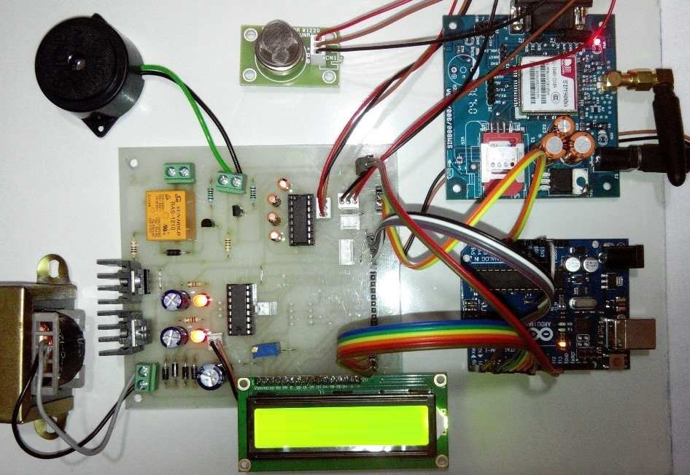

2)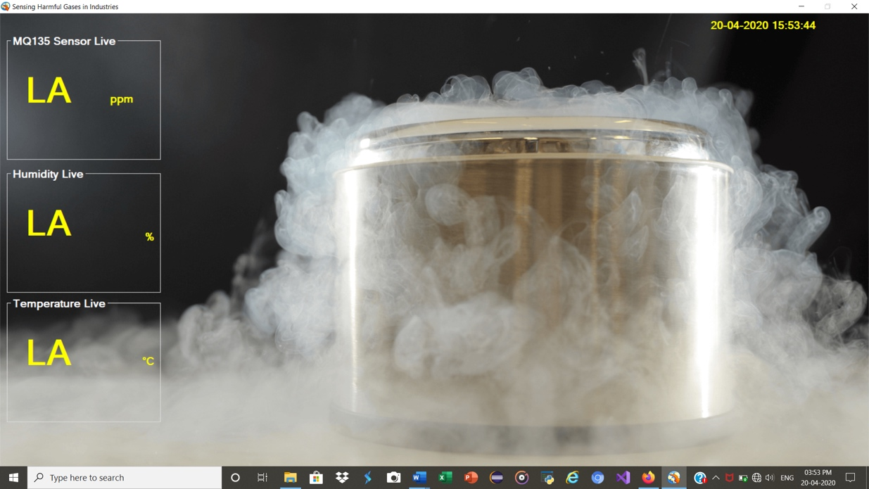

CHAPTER 9:

SOFTWARE REQUIREMENTS

* 1. Microsoft Visual Studio



Visual Studio is an **Integrated Development Environment(IDE)** developed by Microsoft to develop GUI(Graphical User Interface), console, Web applications, web apps, mobile apps, cloud, and web services, etc. With the help of this IDE, you can create managed code as well as native code. It uses the various platforms of Microsoft software development software like Windows store, Microsoft Silverlight, and Windows API, etc. It is not a language-specific IDE as you can use this to write code in C#, C++, VB(Visual Basic), Python, JavaScript, and many more languages. It provides support for 36 different programming languages. It is available for Windows as well as for macOS.

Evolution of Visual Studio: The first version of VS(Visual Studio) was released in 1997, named as Visual Studio 97 having version number 5.0. The latest version of Visual Studio is 15.0 which was released on March 7, 2017. It is also termed as Visual Studio 2017. The supported *.Net Framework Versions* in latest Visual Studio is 3.5 to 4.7. Java was supported in old versions of Visual Studio but in the latest version doesn’t provide any support for Java language.

* 1. Microsoft SQL Server



Microsoft SQL Server is a relational database management system (RDBMS) that supports a wide variety of transaction processing, business intelligence and analytics applications in corporate IT environments. Microsoft SQL Server is one of the three market-leading database technologies, along with Oracle Database and IBM's [DB2](https://searchdatacenter.techtarget.com/definition/DB2).

CHAPTER 10: CODING

Main Program

#include <dht.h>

#define dht_apin 4

int sensorValue;

int a=A0;

int pin=5;

int res=0;

dht DHT;

void setup()

{

Serial.begin(9600);

pinMode(a,INPUT);

pinMode(dht_apin,INPUT);

pinMode(pin,INPUT);

}

void loop()

{

sensorValue = analogRead(a);

res=digitalRead(pin);

Serial.print("Air Quality=");

Serial.print(sensorValue, DEC);

Serial.println(" PPM");

DHT.read11(dht_apin);

Serial.print("Current Humidity = ");

Serial.print(DHT.humidity);

Serial.println(" %");

Serial.print("Temperature = ");

Serial.print(DHT.temperature);

Serial.println(" C ");

delay(3000);

}

The program for LPG gas leak detection monitoring and controlling is done as follows.

*The program listing*

******************************************************************

*************************************************************

******************************************************************

**************************************************************

#include <GSM.h>

#define PINNUMBER " "

GSM gsmAccess;

GSM_SMS sms;

int time=1;

int count=0;

constintanalogInPin = A0;

int buz=13;

int solenoidpin=11;

intfan=12;

intsensorValue = 0;

float voltage;

unsigned int interval = 100;

Char phone_no [ ] = "xxxxxxxxxx";

Char message [ ] ="gas leakage, Kind Attention";

void setup ()

{

/ initialize the Sensor pin as an input: pinMode (sensorValue,INPUT);

/ initialize the relay pin as an output: pinMode (solenoidPin, OUTPUT);

/ initialize the fan pin as an output: pinMode (FanPin, OUTPUT);

While (! Serial)

{

; // wait for serial port to connect.

}

Serial.println("SMS Messages Sender");

// connection state

// boolean notConnected = true;

/ Start GSM shield

/ If your SIM has PIN, pass it as a parameter of begin() in quotes While (notConnected)

{

if (gsmAccess.begin(PINNUMBER) == GSM_READY)

notConnected = false;

else

{

Serial.println("Not connected");

delay(1000);

}

}

Serial.println ("GSM initialized");

Serial.begin(9600);

/* Calibration of sensor*/

Void loop ()

{

int sensorValue = analogRead(A0); // read the input on analog pin 0:

/ Convert the analog reading (which goes from 0 - 1023) to a voltage (0 - 5V): float voltage = sensor Value * (5.0 / 1023.0);

Serial.println(voltage); // print out the value you read:

//*Normal level of gas leakage*//

if (voltage <=1.5 )

{

//"gas detected" message will be displayed in serial monitor Serial.println (" LPG DETECTED in normal level mode.");

delay (1000);}

//* Warning of gas leakage*//

if (voltage >=1.5&& voltage <=4.2)

{

//"gas detected" message will be displayed in serial monitor”// Serial.println (“LPG DETECTED in lower level limit.");

delay(1000);

}

******************************************************************

/ * Explosive level of gas leakage*// if (voltage >=4.2)

{

//"gas detected" message will be displayed in serial monitor”//

Serial. Print (“LPG DETECTED in upper level limit."); Serial.println (“Explosive level of gas leakage.");

tone (buzzerPin,2500,interval); //Ring the buzzer when there is a gas leak detection digital Write (solenoidPin, HIGH);// turn the solenoidPin on (HIGH is the voltage level)

Serial.println (" Solenoid switch is pressed: close");

delay (2000);// wait for a second

digital Write (solenoidPin, LOW);// turn the Pin off by making the voltage

LOW

digital Write (FanPin, HIGH); // turn the FanPin on (HIGH is the voltage level)

******************************************************************

//* Sending SMS to the user *//

While (count <time)

{

delay(1000);

Serial.println(phone_no);

/ sms text Serial.print(message); Serial.println("SENDING"); Serial.println(); Serial.println("Message:"); Serial.println(message);

/ send the message sms.beginSMS(phone_no); sms.print(message);

sms.endSMS();

Serial.println("\nCOMPLETE!\n");

}

else

{

Serial.println(" no gas leakage");

delay(1000);

}

}}

******************************************************************

**CHAPTER 11: APPLICATION AREA**

WSN is used in applications like security, monitoring, biomedical research, tracking etc [63, 64, 65]. The reduction in cost of the sensor nodes and energy may lead revolution as far as applications of WSN are considered. The following listings depict application potential of WSN.

a) Environmental monitoring :

The wireless sensor networks (WSN) is the most momentous technologies in today’s world. The monitoring of numerous parameters occurs in environment as humidity, salinity, blustery weather direction; airstream is done greatly using WSN, also data can be sent on web browser for remote interaction . After employing the WSN in the green monitoring, one can overcome the traditional data logger system.

b) Home automation :

Home automation and its smart intelligence, automatic monitoring and controlling of housing parameters through effective use of WSN technology makes it ingenuous. Using WSN, activities pertaining to the household application can be done automated without any human intrusion. The home automation using WSN such automatic windows and door opening system, to turn off the lights in our rooms, corridor, etc. All these happen automated, which saves electricity consumption, makes our homes smart.

c) Health monitoring :

The health care area uses WSN system more effectively . In hospitals, sensor networks are used to check physiological data of patients, to provide drug diagnosis and monitor patients and doctors inside a hospital. The medicinal applications are of two types: wearable and implanted. Wearable devices are used on the surface of a human body or at close proximity of the user. The implantable devices are inserted inside the human body. WSN performs various health care applications such as patient diagnosis at homes or hospitals, measurement of location of patient body etc. Additionally, an application of body area networks involves collection of information about an individual's health, fitness etc.

d) Air pollution monitoring :

To avoid health hazards, the wireless sensor networks based air pollution monitoring system is used to monitor the concentration of pollutant, toxic, combustible gases. Instead of using wired data loggers system, it uses adhoc deployment for monitoring the gases in diverse areas. Wireless Sensor Network is the most outstanding technology used to collects the information from environment, process it and send it to the user directly . These networks permit the calculation of the physical data at high resolutions and increase thesuperiority and extent of real data o a great extent along with information for applications like toxic waste monitoring, pollution monitoring etc.

e) Forest fire detection system :

The forest fire detection is used to detected a fire has initiated within forest area.The nodes with different sensors are used to measure various environmental affects produced by the fire in the jungle . Using wireless sensor networks the status of the fire can be easily detected and informed to the fire brigade. This is the biggest achievement using WSN technology.

f) Earthquake and landslide detection using WSN :

Using WSN the natural disaster like earthquake will be detected before they occur. Also, the happening of landslides before it occurs will be detected using this system .

g) Smart agriculture system :

For smart agriculture system the competent water administration must be required. The monitoring of crop fields, scheduling of water and crop growth are the key apprehension of precision agriculture system, enhanced using emerging and inventive technology i.e. WSN. The production loss due to unirrigated areas can be improved using this technology.

h) Military application :

Wireless sensor networks must be an integral part of military command controls, communications, computing, intelligence, surveillance, reconnaissance and targeting systems (fig.1.10). In the battlefield context, rapid deployment, selforganization and fault tolerance security of the network should be required [73]. The sensor devices or nodes should provide: like monitoring friendly forces, equipment and ammunition, battlefield surveillance, reconnaissance of opposing forces, targeting, battle damage assessment and nuclear, biological and chemical attack detection reconnaissance, et

**CHAPTER 12: FUTURE SCOPE**

The real success of the sensor network technology depends mainly on its application in eradicating a harmful situation or in maintaining a good one. Designing an efficient application is one of the major challenges and sensor network challenges are application dependent.

Air quality monitoring is a prospective application domain which is of particular value to our country. Large cities with high concentration of industry, intensive transport networks and high population density are major sources of air pollution. Predicting air quality from multiple sources by using modeling is very complicated. So, air quality models are best used for isolated sources or situation. As per the World Bank report quoted earlier, industrial pollution in India is on the more alarming state than industrial production. Hence, controlling and monitoring air pollution round the clock is a social imperative.

This study proves that WSN could be a useful mechanism for this double task. The air quality data generation through air quality monitoring network available today, involves large number of monitoring agencies, personal and equipment for sampling, chemical analysis and data reporting etc. The involvement of several agencies increases the probability of variations and personal biases reflecting on the data. Therefore, the air quality data statistics available today is being recognized to be more indicative rather than absolute and perfect.

To carry out perfect air pollution models, namely scientific research, air management and decision making, air pollution control, environmental impact and air pollution episodes, continuous air pollution monitoring using sensor network is the only solution. It is mandatory to possibilities of network design of building an efficient data collecting system for continuous air pollution level monitoring using sensor network in an industrial area, with available resources are discussed. The models outlined are :

Generic architecture of sensor network in Industrial Air Pollution Monitoring (IAPM) through internet equipped with micro server in industrial premises and meta server in pollution control board. Design of proposed District Air Pollution Network (DAPNET). Design of simple short distance sensor field setup and sample long distance sensor field that is topo sketch showing air quality monitoring sensor locations in XYZ industry.

One of the interesting three dimensional node location scenarios to monitor SPM (Suspended Particulate Matter) level in stack of an industrial area.

Large scale industries are having industrial control systems namely Distributed Control System (DCS) to form communication network of various critical infrastructures of electric, water, oil, gas etc., In addition to these it is proposed to form a modern field bus system with Sensors Marshalling Panel (SMP) to collect data from various sensors available in different units of an industry. Multi source and single sink topology model to collect air pollution data.

The network design methodology can be very useful for management and control of environmental pollution to ensure a pollution free environment and also to get real picture of air pollution models.

In WSNs design logical and physical topology plays major role. The logical topology is a method used to pass information between them. From the existing air pollution monitoring and reporting methods, the following points are concluded.

Spot or short sampling cannot give adequate data on the nature and the magnitude of an air pollution problem. Collected data is treated as indicative rather than absolute. Factors related to continuous monitoring are number of communication, energy consumption and bandwidth. The possible alternate method of reporting is aggregation. There is a lack of objective criteria for choosing an appropriate aggregating method. In statistical point of view, if the number of samples increases then the possible error rate decreases.

Hence, in air pollution monitoring system, instead of reduced packet size and number of communication, usefulness of data is important. If the samples are collected and maintained once, it is possible to answer a wide range of queries out of network with accuracy.

An approach of monitoring continuously using various sampling techniques, implemented using Castalia simulator. Initially, stack monitoring through single source and a sink is carried out based on two schemes, namely at the rate of particular sampling interval and sampling greater than threshold value. Next, to test scalability, the sampling pattern of small network is carried out by constructing a network with four sources and a sink. The four schemes tested are:

* Periodic time sampling – The sensors communicate their data continuously at a pre specified rate that is at the rate of particular sampling interval (Application Sample Interval = 1000s for all nodes).
* Multiple sample rate - Different sampling interval for different nodes in a network to record large emission sources frequently (Application Sample Interval = 1000s for one node and 2000s for all other nodes).
* Threshold value sampling or event driven – The sensors report information only if an event of interest occurs that is to report values greater than the defined pollution threshold (150µgm).

Time period sampling like duration of first shift, morning hours, peak hours, shut down time etc. to measure variation in pollution levels (for example sampling from the time period 15 minutes before - 27900s to 15 minutes after - 29700s for the shift starts at night 12‟o clock -28800s).

Various sampling methods can be used to determine the concentration of air pollution and these may be taken as guidance to compare results in different ways. Also, the benefit of different sampling technique is to collect only valuable data and hence the amount of data transmitted to the sink, RAM memory used and transmission channel utilization are reduced. The optimization in sampling may be possible in terms of the parameters, namely node number (self), sensed value (thedatavalue), and simulation time (simTime).

The major outcome of the simulation schemes is the value of spent energy obtained for each node. The energy consumed for each node is same irrespective of the distance between source and sink. This is because the energy consumption is based on the time the radio is ON (Listening, Transmitting or Receiving). If two nodes have the same ON time then they will have the same energy consumed. So, it is necessary to consider the possibilities of minimizing consumed energy.

**CHAPTER 13:**

**CONCLUSION**

This project is the integrates a Wireless Sensor Network (WSN)-based harmful gases sensing system using different gas sensors and whose sensed data is passed through IOT gateway to server. This system is very simple and integrated model as compared to the other existing air or gases quality monitoring systems. This project is also used for ensuring healthy atmosphere for the people who are mostly exposed to harmful gases. In future, this prototype can be extended since in this project X-bee is used which has limited range up to 100m so we can increased the distance by using X-bee Pro up-to km.

The computing is the main part of the WSN node and is wired about an arduino nano microcontroller. This microcontroller is having on chip analog to digital converter with 10 bit resolution. To realize autonomous operation, the WSN nodes are powered with 12 V DC rechargeable batteries. Thus, the WSN nodes are designed and the results of implementation support the preciseness and The computing is the main part of the WSN node and is wired about an arduino nano microcontroller.

**Future Implementations**

The sensing alarm system safety features can also be

improved by adding another function to check the sensor’s condition in case the

sensor is not working properly or if the sensor’s calibration has been displaced/

deliberately changed.

In near future, our motto is to add automatic windows opening system

application when the gas leakage is detected within the room / home.

To implement android apps

**REFERENCES**

[1] Walter Fuertes and Diego Carrera., “Distributed System as Internet of Things for a new low-cost, Air Pollution Wireless Monitoring on Real Time”, IEEE/ACM 19th International Symposium on Distributed Simulation and Real Time Applications, 2015.

[2] Chen Xiaojun, Liu Xianpeng and XuPeng. “IOT- Based Air Pollution Monitoring and Forecasting System.”, International Conference on Com- puter and Computational Sciences (ICCCS) IEEE, 2015.

[3] Deepak Mehetre and Shwetal Raipure “Wireless Sensor Network Based Pollution Monitoring System in Metropolitan Cities”, ICCSP conference, 2015.

[4] Petros Spachos “Real-Time Indoor Carbon Dioxide Monitoring through Cognitive Wireless Sensor Networks”, 10.1109/JSEN.2479647, IEEE Sensors Journal, 2015

[5] Vikhyat Chaudhry, “Arduair: Air Quality Monitoring”, International Journal of Environmental Engineering and Management.ISSN 2231– 1319,2013

[6] Jadhav D. A., “Air pollution monitoring system using Zigbee and GPS module” , International Journal of Emerging Technology and Advanced Engineering, Volume 3, Issue 9, September 2013.

[7] Nagesh P. Tembhurnikar,Dnyandeo S. Khemnar, Amol R. Kasar, “WSN Based Air Pollution Monitoring System”, International Journal of Science and Engineering Applications (IJSEA) Volume 2 Issue 4, ISSN - 2319- 7560, 2013.

[8] Raja Vara Prasad Y1, Mirza Sami Baig., “Real time wireless air pollu- tion monitoring system”, Ictact Journal On Communication Technology: Special Issue On Next Generation Wireless Networks And Applications, Volume – 2, Issue – 2, June 2011

[9] Neha R. Rewatkar,Prof. Deepali M. Khatri, “A Review: Cost Effective IOT Based Air Pollution Monitoring and Air Quality Analysis” , In- ternational Journal on Recent and Innovation Trends in Computing and Communication Volume: 5 Issue: 1 (Special Issue), ISSN: 2321-8169, January 2017

**PAPER PUBLISHED , CERTIFICATES & POSTER**



**Link : http://ijsrcseit.com/CSEIT206125**